# SOLID Principles

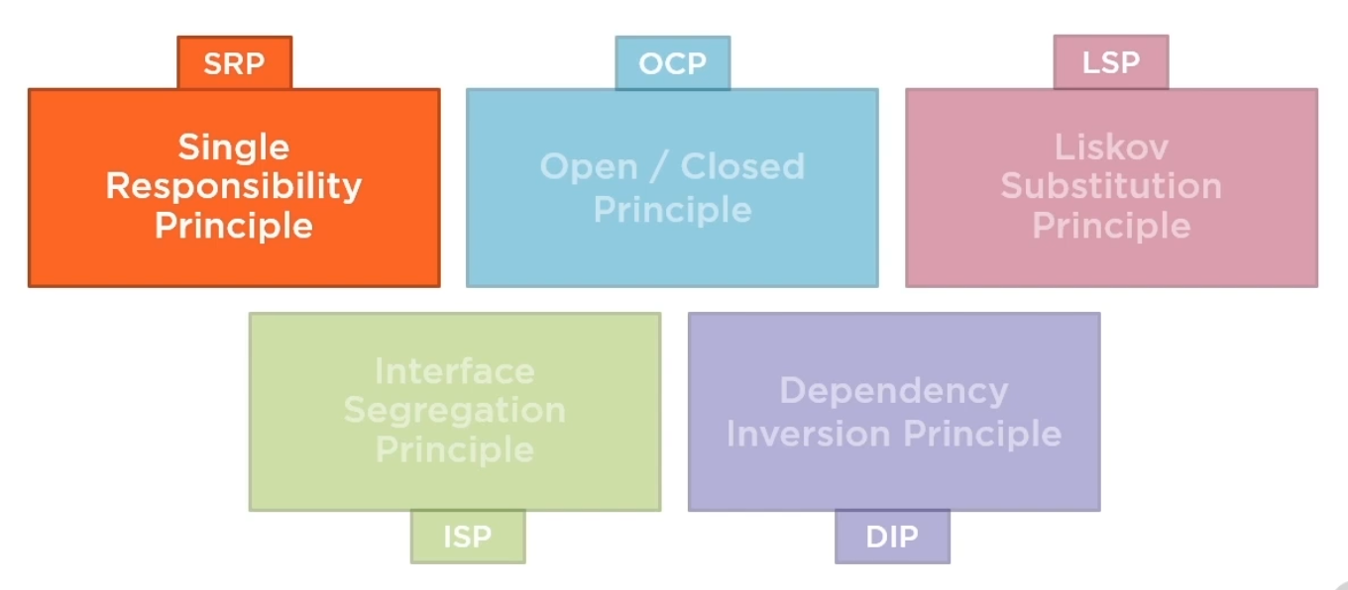

The first thing is to know when to apply these in your application. Now applications may be built according to a

1. TDD – Test Driven Development
2. DDD – Domain Driven Development

But to apply these principles in your application, you must have to follow PDD which is Pain Driven Development. This means that write your code in the simplest form you know.

Trying to apply these principles from scratch when creating an application is a form of premature optimization of your application design.

When your application grows, look for regions which are painful to work with and then use these principles to guide it and redesign your code.

## Single Responsibility Principle

Each software module should have one and only one reason to change.

A module in case of C# might refer to a class or a function. The individual classes and methods in our applications define what the application does, and how it does. We can easily improve the design of our software if we are able to separate the what from the how. We do this through delegation and encapsulation.

Classes should encapsulate doing a particular task in a particular way.

Responsibility is a decision our code is making about the specific implementation details of some part of what the application does. Responsibility is the answer to a question of how something is done.

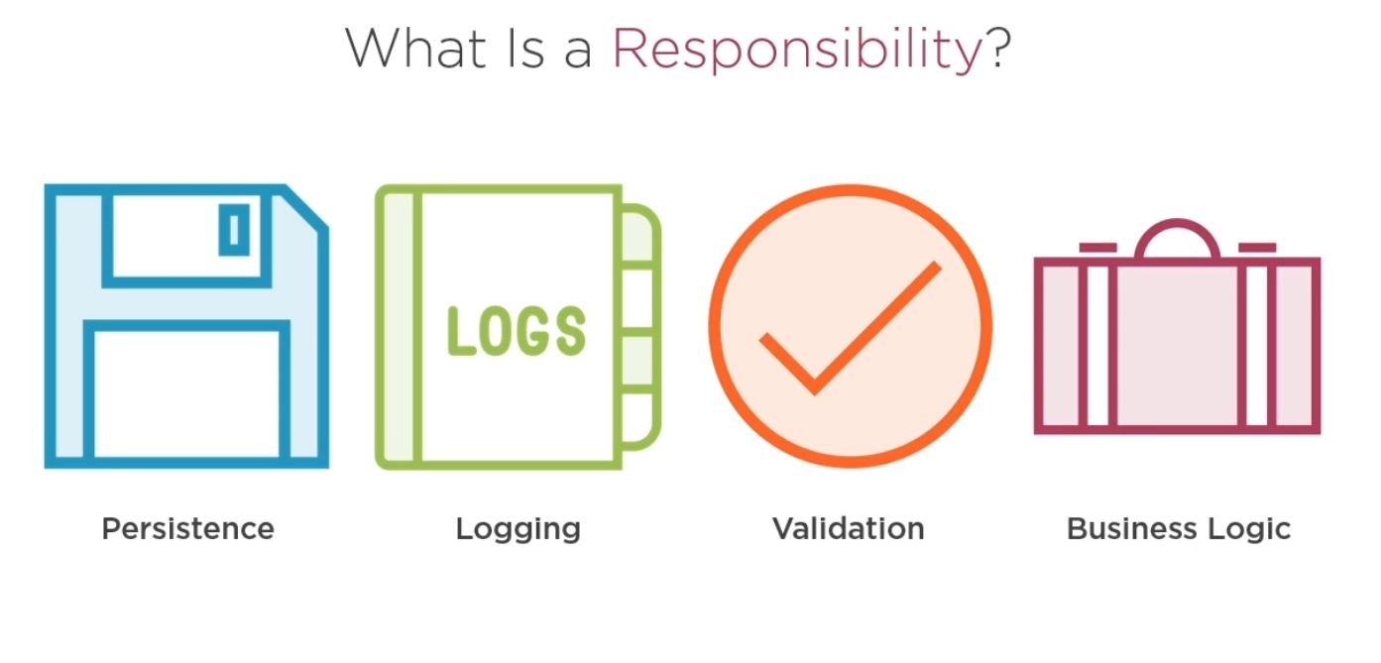

SRP suggests that modules should have only one reason to change. These modules may be revaluated in the future.

Persistence might change from files to database. Validation rules might need to be updated. Logging might need to be changed to make it more extensive. Of course, business login might change at different times in the future for different reasons.

Each responsibility is a different axis for change.

SRP is closely related to the concept of couple.



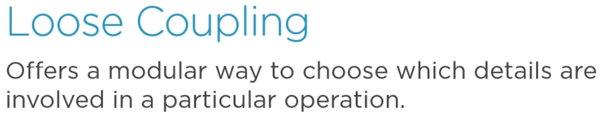

In loose coupling, one class will be responsible for higher level concern and will delegate to other classes who are responsible for the details of how to perform lower level operations. this tells another principle called separation of concerns.

Separation of concerns suggests that programs should be separated into distinct sections that each address a separate concern or a set of information that affects the program.

Ideally, high level code should not know about how low level details are implemented nor it should be tightly coupled to specific details.

Another concept that is closely related to coupling is cohesion. Cohesion describes how closely related elements of a class or module are to one another.

Classes that have many responsibilities will tend to have less cohesion than classes that have a single responsibility.

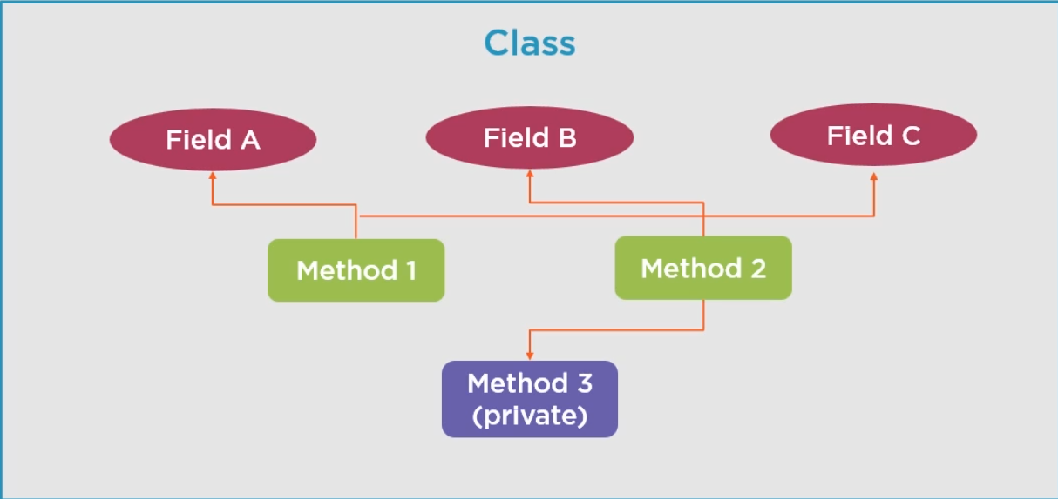

This class is not much cohesive because methods does not share much data or behaviour with one another.

We can reorganize the same diagram like this.

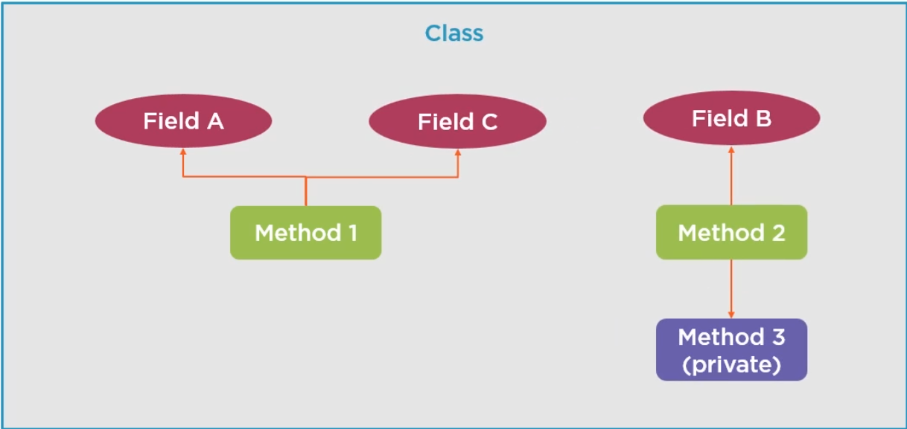

Now it is easily visible that Method1 and Method2 share very little with one another.

In fact, we can refactor them into separate classes.

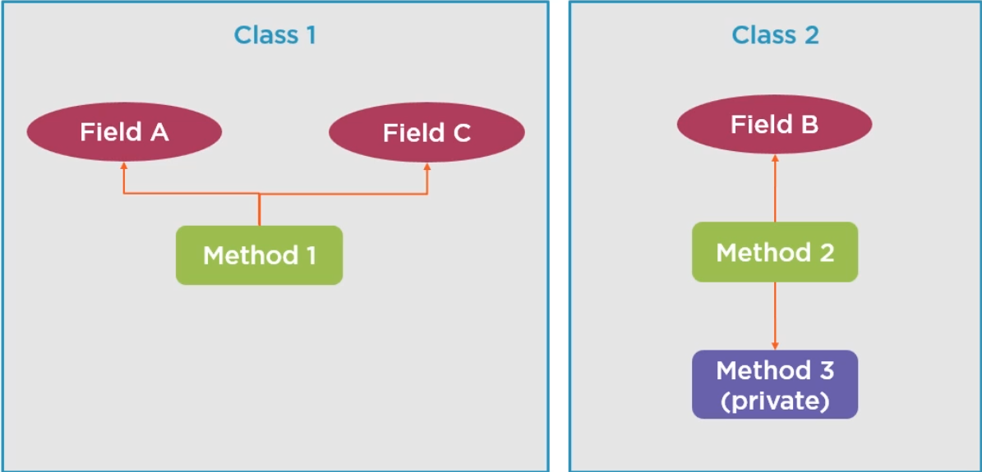

Now these are much more cohesive than the original

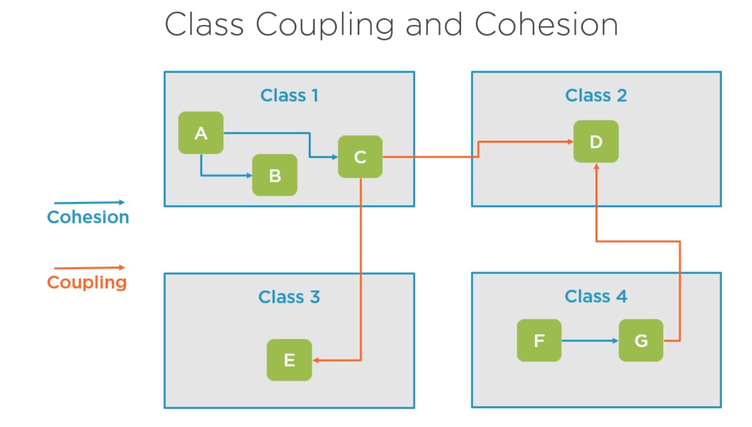

Relationship within each class is cohesion and relationships between classes is coupling. This coupling might be tight or loose depending on how it is implemented. In most cases, loose coupling is preferred because it results in code that is easier to change and test.

Let’s Build an ardalis Insurance Rating Engine Application from scratch and apply SRP to it.

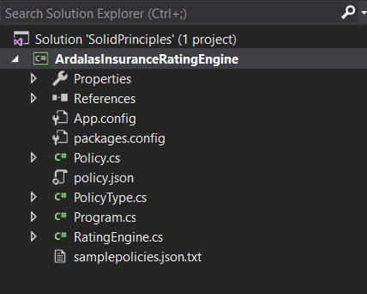 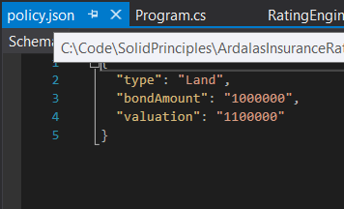

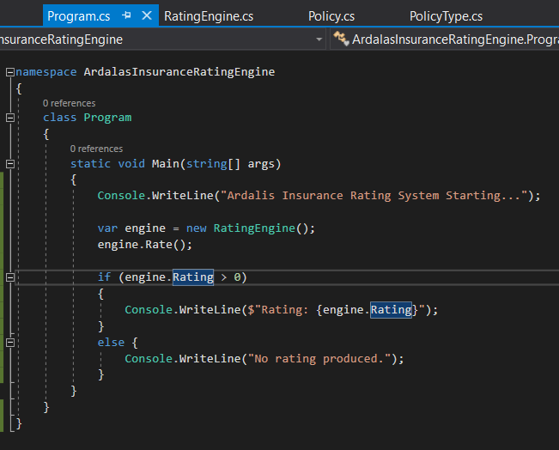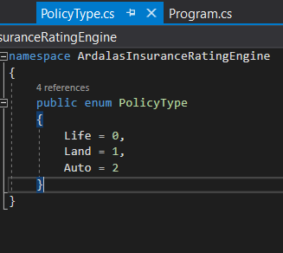

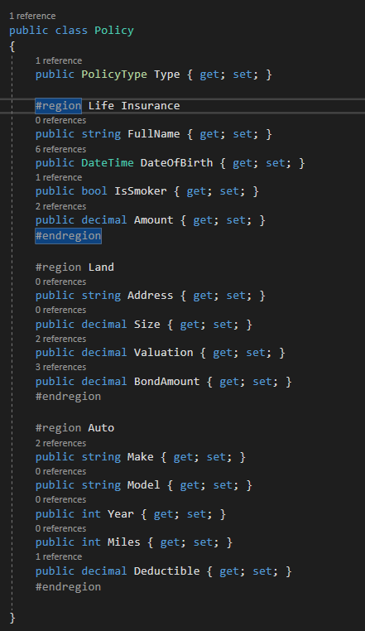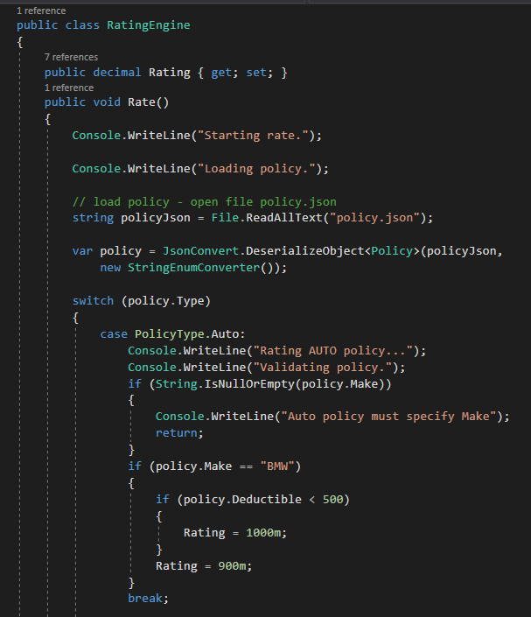

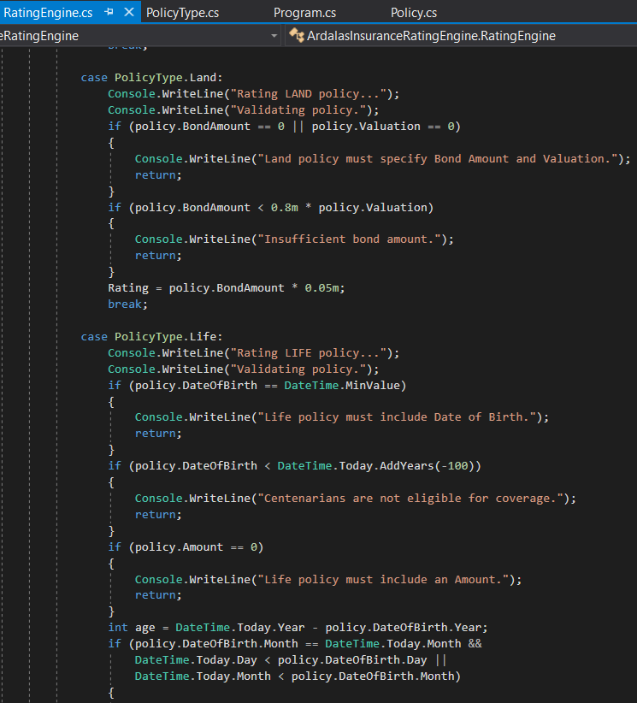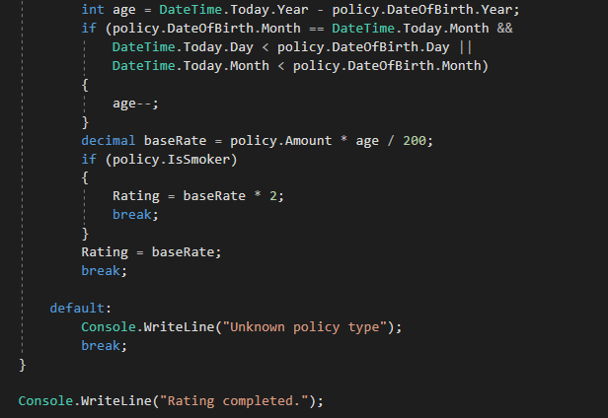

The application flow is like this. This is a console application so Program.cs runs first.

1. Program.cs initializes the RatingEngine class and calls the Rate method. Then it prints the rating on to the console.
2. The RatingEngine class Rate method
   1. First loads the policy.json file and deserializes it to get a policy enum.
   2. Then based on the policy type it validates the conditions and when the conditions are met, it calculates the rating based on some business logic.
3. The PolicyType.cs is an Enum class
4. The Policy.cs is a model class



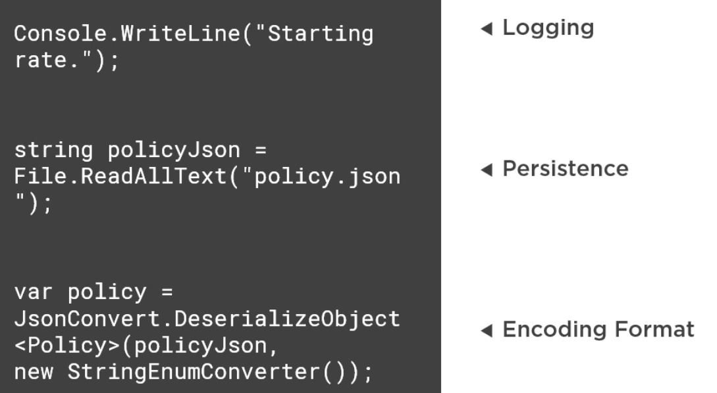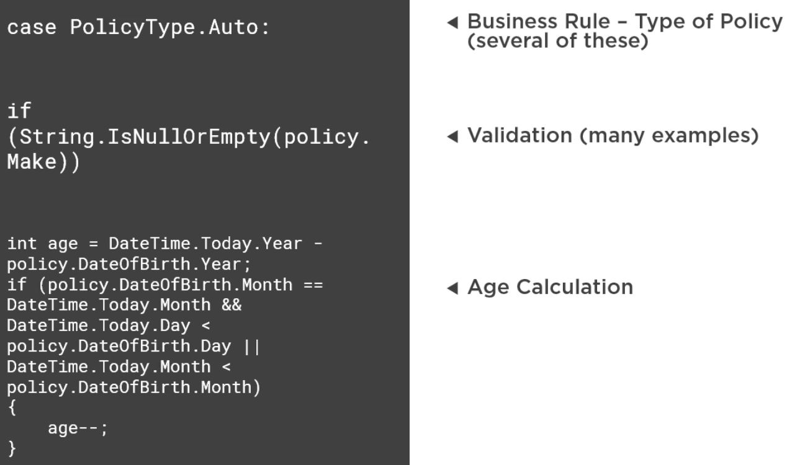

If we change our decisions then

1. Console logging might need to be converted to something else
2. Reading data from file system might also require change in the future if we change our persistence logic.
3. We have hardcoded the dependency on json format. If later we want to use YAML, XML or INI files or some custom binary format, we will again have to change our responsibility.
4. We also have different type of validation, business logic and formulas for age calculation within this file. Any change coming from anywhere within the company with this regard might require us to touch and implement the logic again in this file.

Responsibilities has a direct relationship with testability. When classes have many responsibilities, it becomes more difficult to test them.

In general, testing classes with many responsibilities results in tests that are longer and more complex. Frequently the tests are brittle because they are coupled to the implementation and a change to any responsibility might break tests for any other responsibility in the same method or class.

Below is an example of a test we might write for our rating engine.

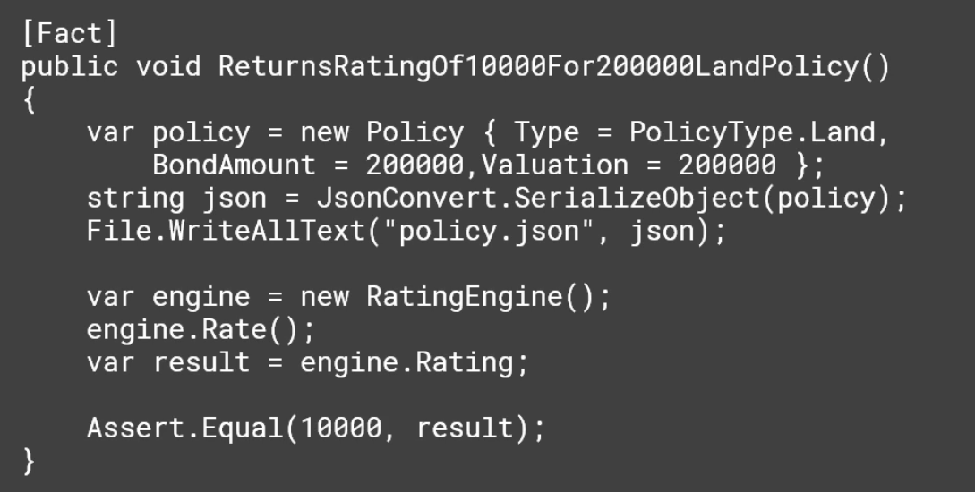

Notice that it needs to overwrite the policy.json file on every test run making running test in parallel impossible and likely creating problems for us at some point with locking and contention that might result in unexpected test failures.

Now let’s refactor the RatingEngine.cs class with SRP in mind.

1. We can create a new class for logging. For now, it will have only one line of code to log to console.

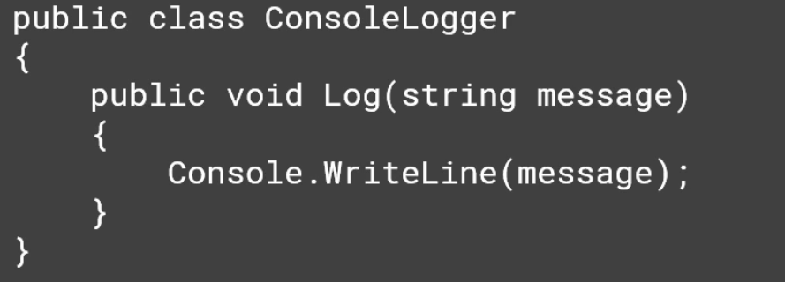

1. We can add a property to RatingEngine with this new type.

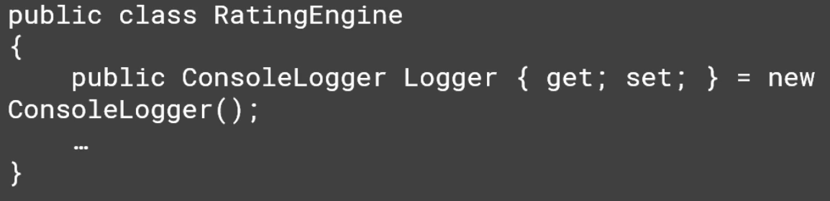

1. We will replace all the Console.Writeline with Logger.Log
2. Similarly, we can create a class for persistence.

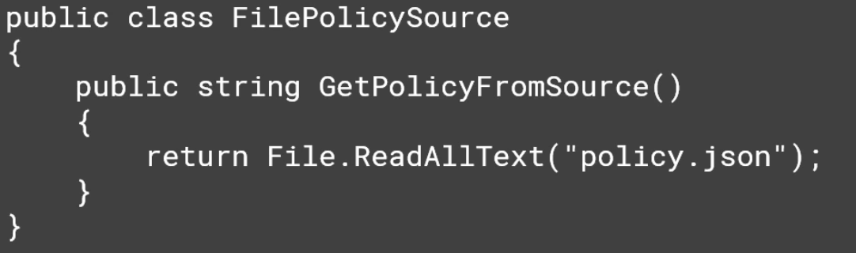

1. Next, we create the property for this to the RatingEngine and we use this property instead of working directly with low level file IO libraries inside of the engine.

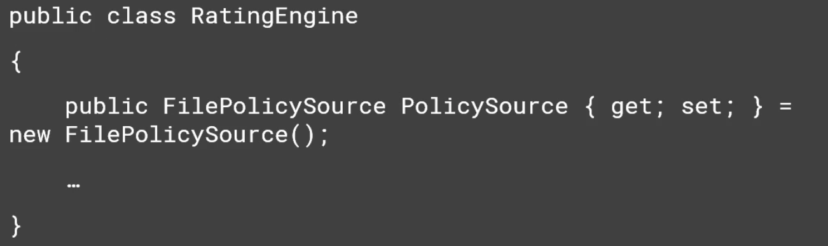



After applying the SRP to Logging, Persistence and Encoding, our code at start of the Rate() method look like this

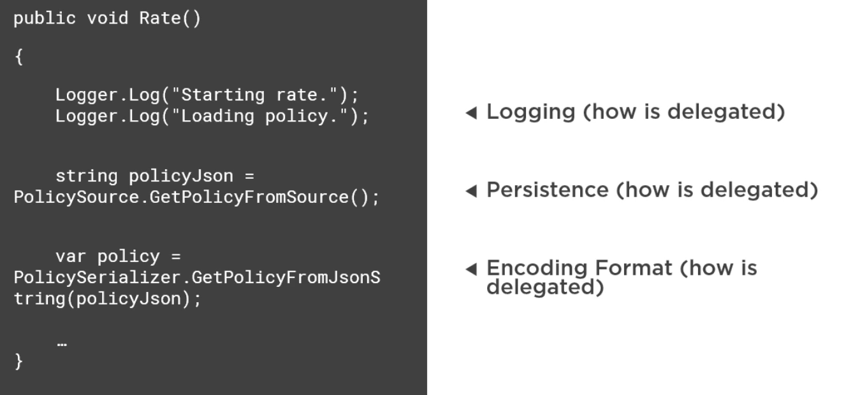

It is now delegating the details to other classes. Each of these other classes only does one thing. Each of these new classes can easily be tested

## Open Closed Principle

It is the structuring of code in order to make in extensible in the future.

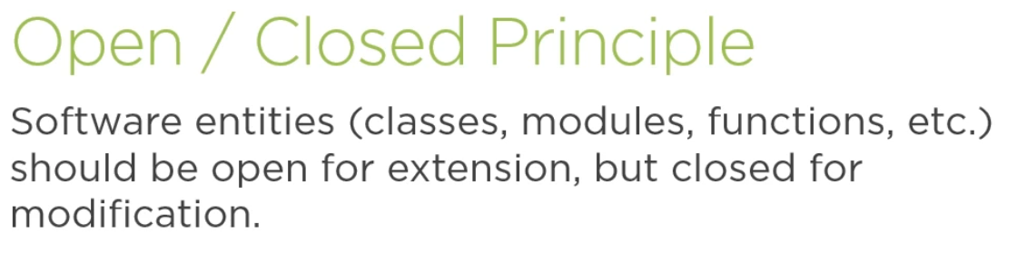

It should be possible to change the behaviour of a method without editing its source code.

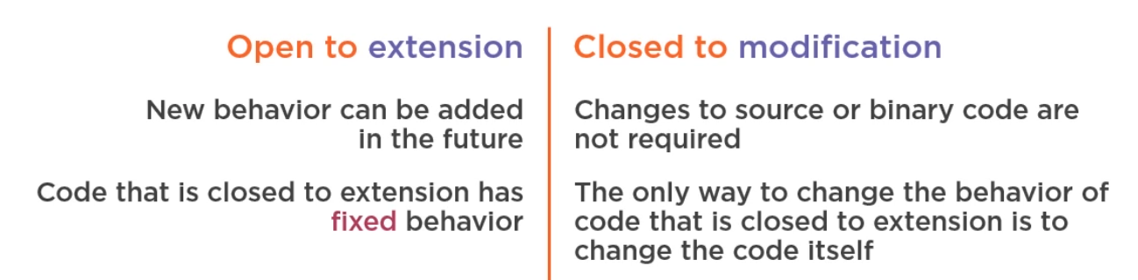

Since code that is closed to extension has a fixed behaviour and to make it open for extension one need to change the code inside of it, it is not closed for modification.

We need closed for modification because, the less we change the source of our code, the less likely it is to introduce new bugs into it. We also won’t need to redeploy that code. And this reduces the impact of downtime and impact on downstream dependencies on that module.

Code that is open for extension usually has fewer conditional statements then closed that is closed to extension, which means it is probably simpler code that is easier to understand and test.

Bug fixes is an exception to the Open closed principle obviously.

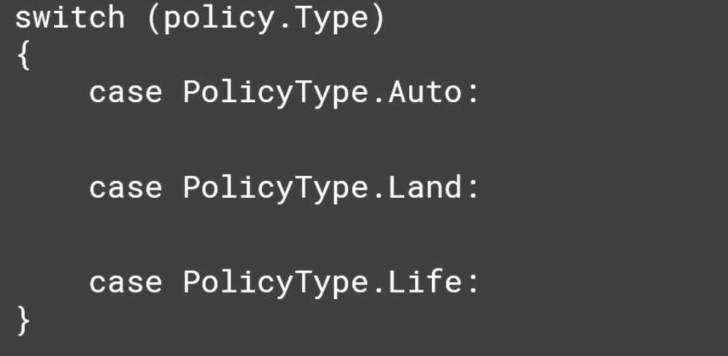

In the current implementation of the application, we have a switch case that determines which policy type is being worked on. We can think that when the application was first written, we only supported one kind of policy, but as additional requirements came in and the businesses needs expanded, other types were added.

We may need to add some in the future. Given that the case, next time a requirement comes in to further expand the switch statement, we should strongly consider refactoring to apply OCP.

Why we didn’t start with OCP in the first place. In real life scenario, it comes to balancing abstraction with actual implementation and delivering working software.

Remember that the code that is extensible in any possible direction is infinitely abstract. You need to balance that abstraction with concreteness. Abstraction also adds complexity.

If you have code that only does one thing is completely concrete. There’s no abstraction. There is no way to change what it does. We want application that can flex in the ways the we will need to as they are maintained and extended. We need to able to predict where that variation will be needed and then apply that abstraction when the need becomes apparent.

The below code is extremely concrete.

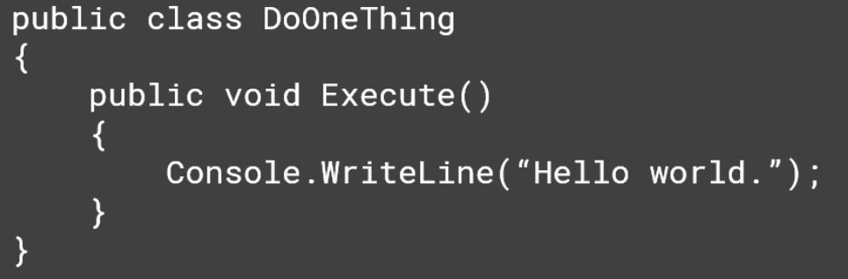

The only way to change its behaviour is to change its code.

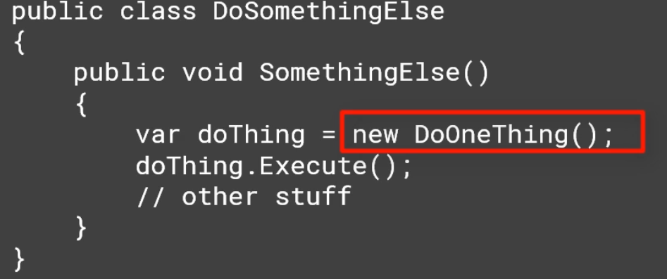

Also, when you use the new keyword, you are being extremely concrete. You are gluing the calling code to a specific concrete implementation.

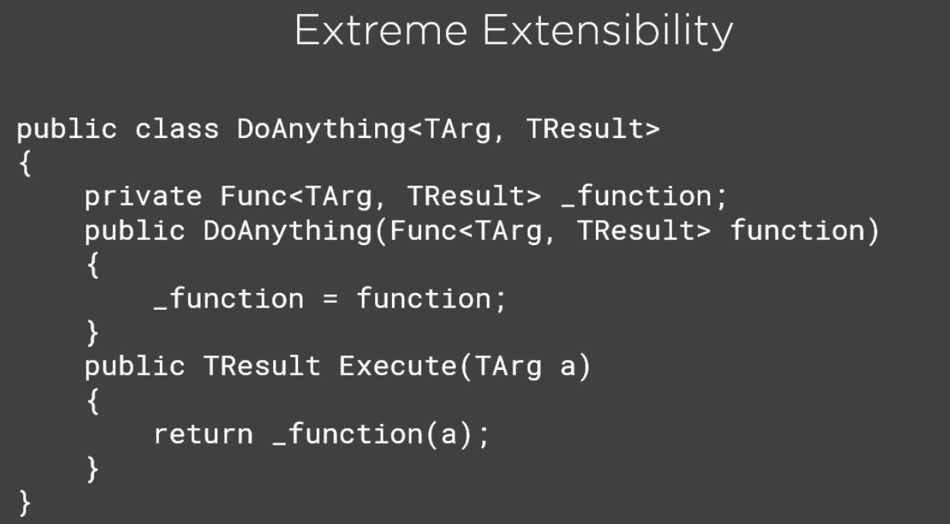

Now the above code is extremely extensible. It can literally do anything because it doesn’t actually do anything itself. 100% of its functionality is passed into it.

Parameterizing behaviour is at the heart of many approaches to apply the open closed principle.

Another example of extreme abstraction is below.

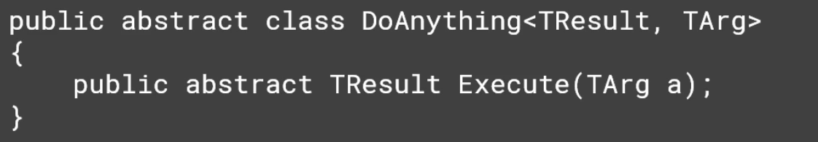

This relies on inheritance instead of composition and uses an abstract base class.

If you are going to balance between extreme concreteness and extreme abstraction, how can you decide where to make you application extensible.

One proven approach is to start out by being concrete and then wait and see how the application evolves over time. When changes to the behaviour are needed, just make them in the code for the first time or two. However, by the third modification, you should be strongly thinking about adjusting the code to follow OCP since it seems likely based on the past experience that the application is likely to continue to change in this manner in the future.

Typical Approaches to OCP

1. Parameters - > this is the simplest approach and based on the parameters passed into methods/functions we can change its behaviour.
2. Inheritance -> Many design patterns leverage inheritance to facilitate OCP. Using object inheritance, you can change the behaviour of the underlying type without having to change or even have access to that type simply by creating a new child class that inherits from it.
3. Composition/Injection -> Instead of placing logic directly within a class, the logic is provided by another type the class references. Instead of hardcoding the reference to the other type, the reference is provided through a technique known as dependency injection.

C# also supports another for of extension through extension methods, which can add additional functionality to types without modifying the types themselves.

Parameter based extension

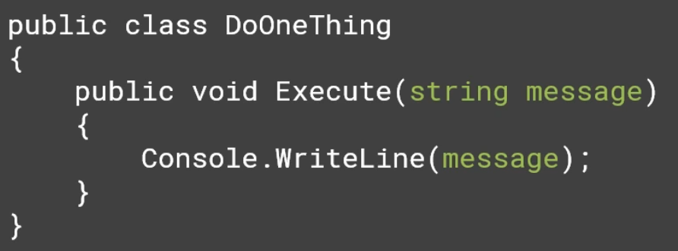

Now this can print any king of message instead of just a fixed message in the case of extremely concreteness above.

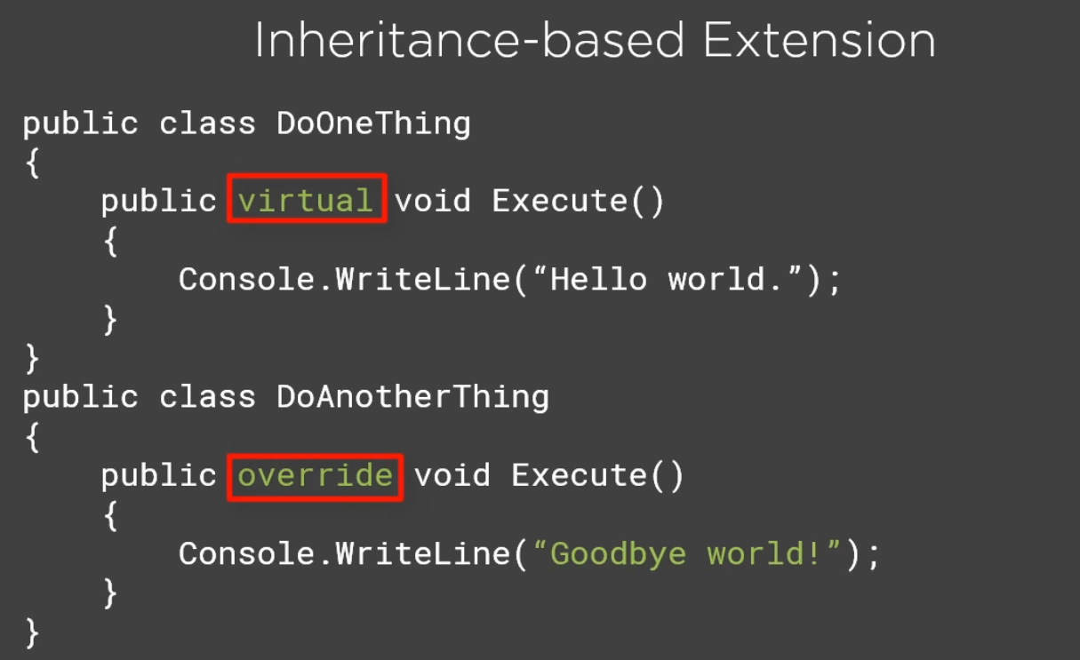

We can mark the method virtual in the base class and then override it in the child class to make it extensible.

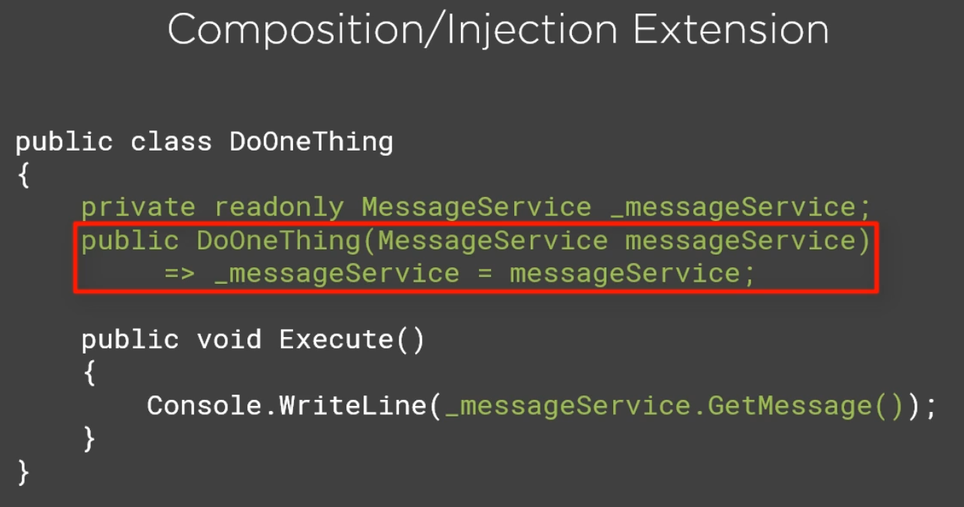

This approach involves injection. In this example, we have pulled the responsibility of generating messages out into its own class called MessageService. The Execute() method simply uses an instance of this class to get the message to display.

The Execute() method or the constructor could have just instantiated the service using the new keyword but this would have glued this class to that specific implementation. It would no longer be closed to modification for changes that might require a different kind of message service and it would introduce tight coupling.

Instead, the MessageService dependency is passed into the constructor and set to a private readonly field. This is also an example of Strategy Design Pattern.

Once you have identified an area where you would like to apply OCP in your application, you should **prefer implementing new features in new classes**. Especially when working with large legacy code bases, this can be a way to add functionality without increasing the complexity of the existing system.

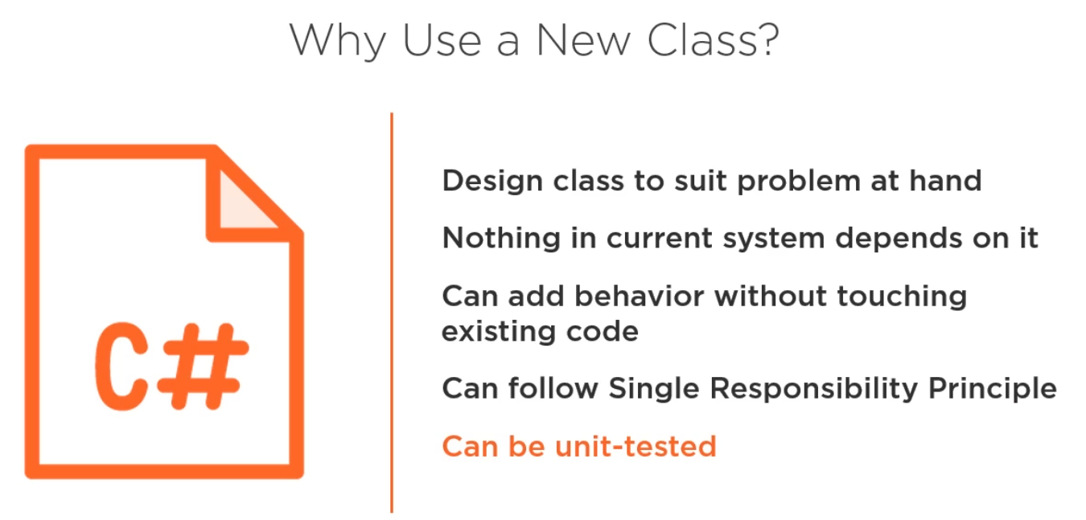

Now let’s apply the OCP to our InsuranceRating application. Let’s now also extend our RatingEngine to support for Flood insurance.

Now to add a support for Flood Insurance, we need to add a case for Flood in our switch statement. We have to so that again for any additional type of policies that company might support in the future. So, we can take this opportunity here to apply Open Closed principle and make it so that we can find a way to add additional extensions of behaviour to the Rate() method without having to continually come in here and change these individual case statements.

The first step is to take the logic from each one of the switch statement case and move it into its own type. Meaning for each case in the switch statement, we are going to have a class that will take care of the logic for that switch case.

Once we have completed that refactoring, we will be able to instantiate the appropriate type based on the policy type that we are trying to deal with. As we add additional kind of policies we want to support we will then only need to add new classes.

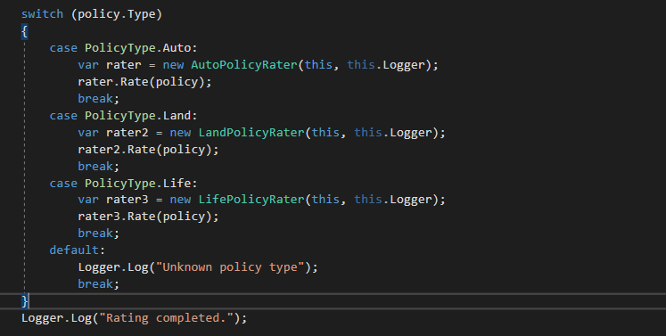

We have Implemented the AutoPolicyRater, LandPolicyRater and LifePolicyRater. Now the switch statement in the RatingEngine.cs class has become much shorter. But we are not finished yet. To extend it for the Flood insurance, we still need to come to this class for modification. So, this RatingEngine class is still not closed for modification.

To make it closed for modification, we need a Factory that will eliminate the need of switch statement inside of the RatingEngine class.

Using **the factory design pattern,** we are creating a new class called RaterFactory that has a method Create(), which for a given policy will take in anything it needs which in this case is the engine and determine which type it wants to return.

The switch statement still exists but it has now moved from inside of the engine and into the factory. This also helps us in implementing the Single Responsibility principle. Because now the RatingEngine is no longer responsible for determining which type and which logic should be used based on the type. Now, determining what the type is only the responsibility that only the factory has.

The RaterFactory returns an instance of the PolicyRater class based on the type of policy. Since all of the PolicyRater classes have logger and policy injection common, we have created an abstract class Rater.cs that does the initialization of these injection for us. This abstract class is inherited by all other PolicyRater classes.

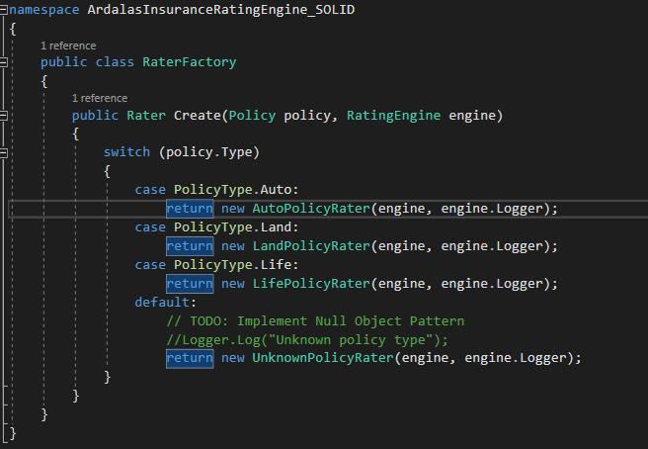

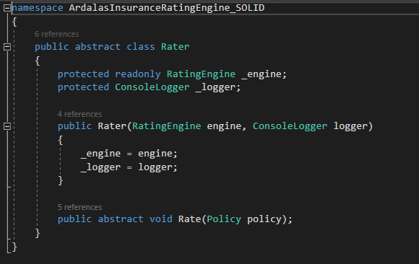

After applying all these, the RatingEngine class Rate() method looks like this

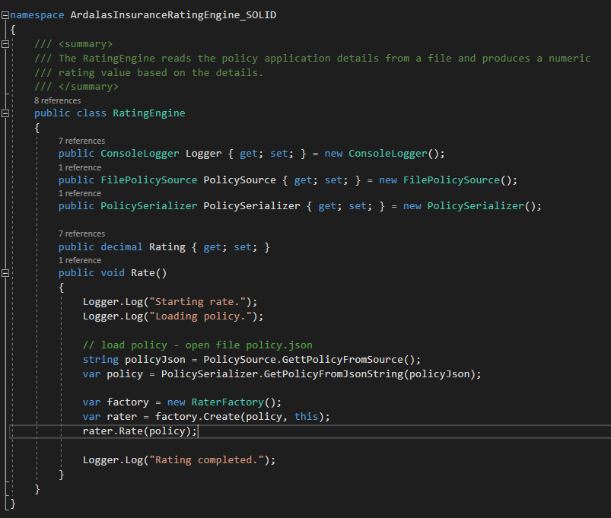

Now whenever the company decides to add a new policy, we do not need to change any code inside of the RatingEngine class.

All we have to do is to create a new PolicyRater class as for Flood insurance, we will create a FloodPolicyRater class and implement the rate() method for flood insurance in it. Then, we will add it into our factory class so that an instance of FloodPolicyRater can be obtained.

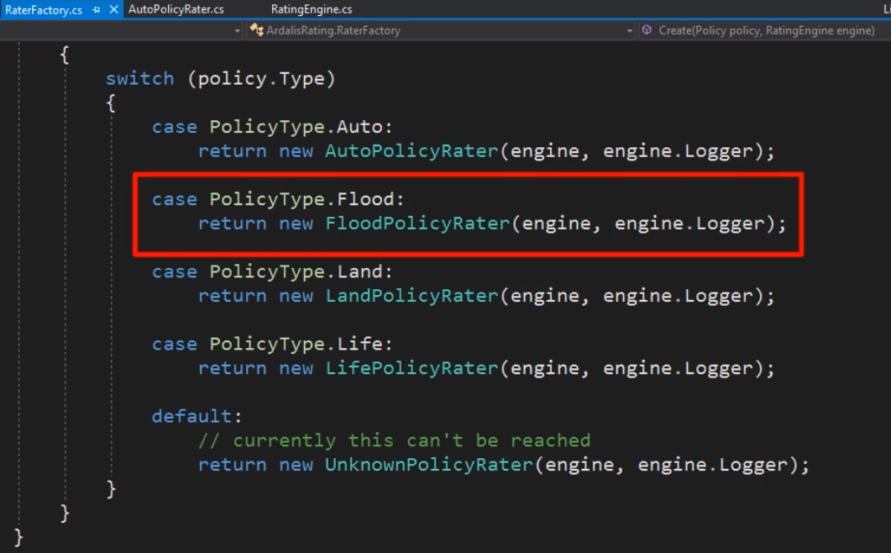

With this is place, you can see that the Rate() method of the RatingEngine class is not open for extension but closed against modification. We don’t need to change the rate method in order to add support for new policy types.

**Now, if we notice the RaterFactory, we can see that this factory class is not closed for modification.** The open closed principle can be applied to this class as well.

As of now, any time we implement a new policy in a separate class, we have to come to RAterFactory and change the Create() method switch statement. We can eliminate the need of switch statement by using **Reflection.**

In our case, we are going to use a naming convention to allow us to instantiate the appropriate class instance based on the name provided inside of the policy type in the json document. In the case we don’t find a matching class name, we will return null.

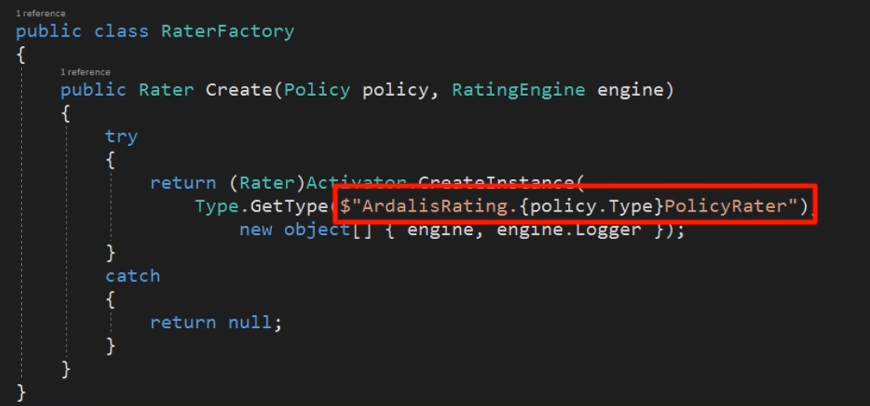

This means that when the factory returns null, the Rate() method inside of the RatingEngine class might throw a null reference exception. So, to avoid this, we need to also check if the rater returned is null or not. We can do this easily by doing this

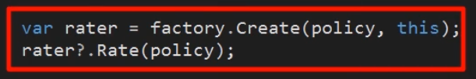

In this case, if the rater is null then the rate method will not be called.

One area where OCP is especially important is in libraries and nuget packages. Whether public or internal, nuget packages are closed for modification by their consumers. If new behaviour is required, generally, the package author must add it and publish a new version of it.

Packages should also be closed for modification in a different sense meaning they should avoid breaking existing client code that depends on them when they are updated with new behaviour.

Of course, packages should also be open to extension so that consumers can employ the functionality of the package in a way that suit their unique needs.

## Liskov Substitution Principle

It provides guidance on how to properly use inheritance in OOP like C#.

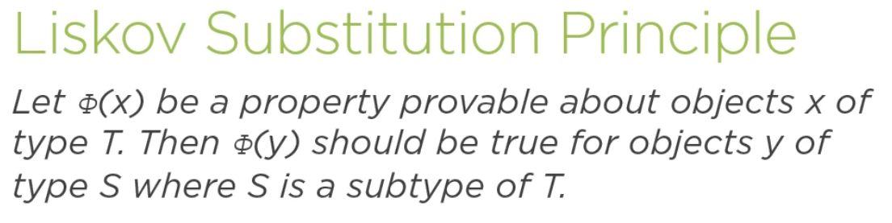

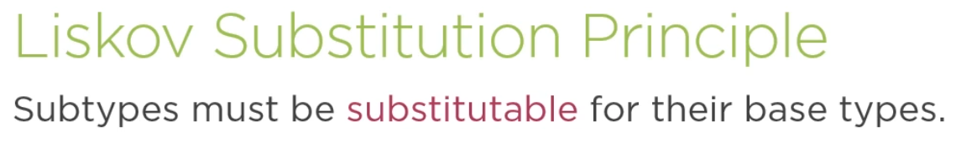

Objects and their relationships with one another can be determined using two characteristics.

* Inheritance -> the IS-A relationship like, an eagle is a bird
* Proeprties -> the Has-A relationships like an address has a city

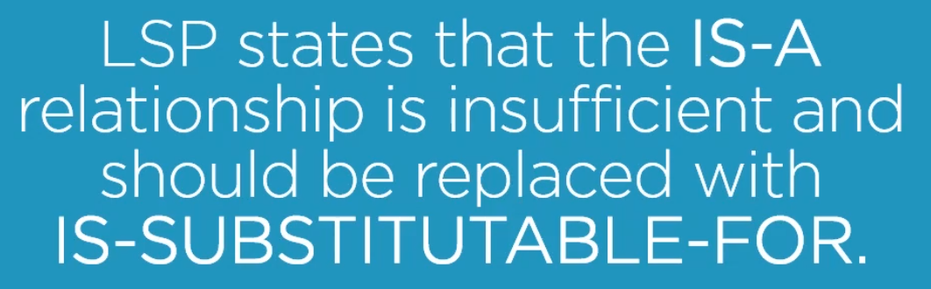

To understand this, let’s examine the classic shape problem.

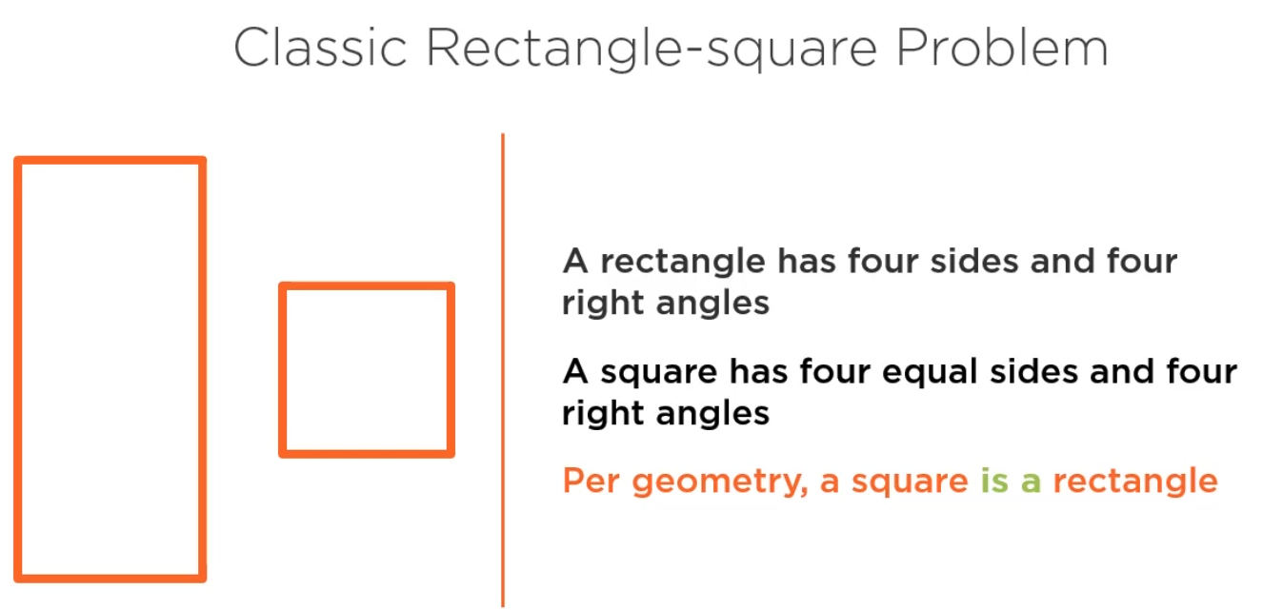

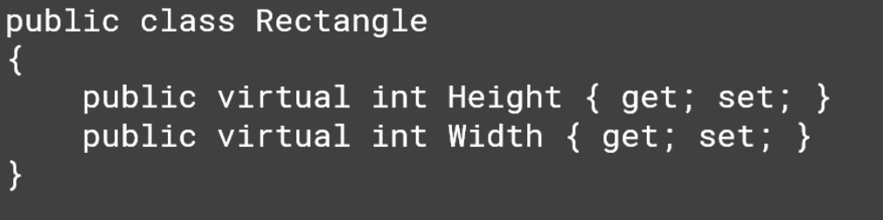

Area Calculator Utility

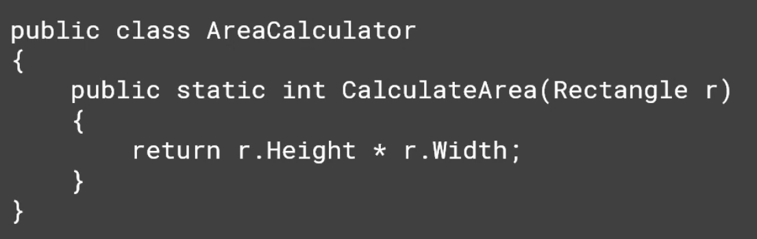

Square (a subtype of rectangle). Every time a width or a height is set, the other is also set with the same value.

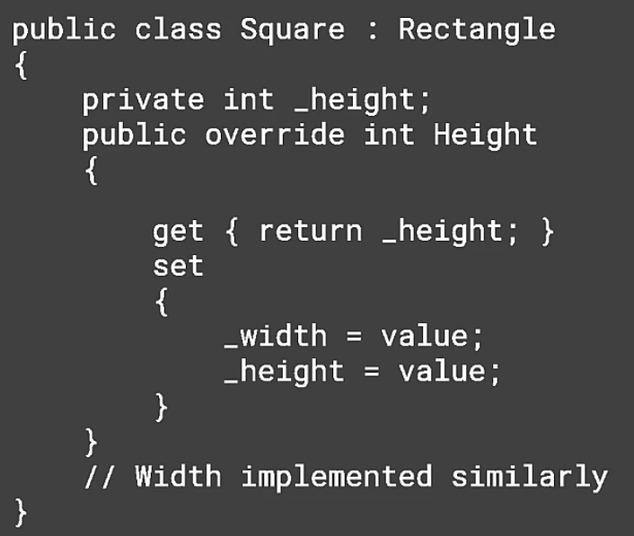

The Problem – when user wants to work with a rectangle but uses a square instance.

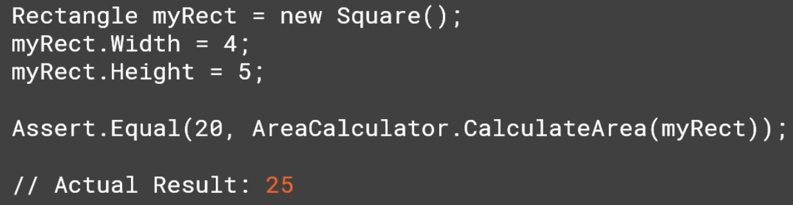

Square has an invariant that its sides must be equal. Rectangle has an invariant that it sides are independent. The current design breaks rectangle’s invariant and thus violates LSP. As a result, when we try to substitute an instance of a square into code that is expecting to work with a rectangle and it’s invariance, we get unexpected results.

One simple solution is eliminating the Square class entirely and instead use a IsSquare flag.

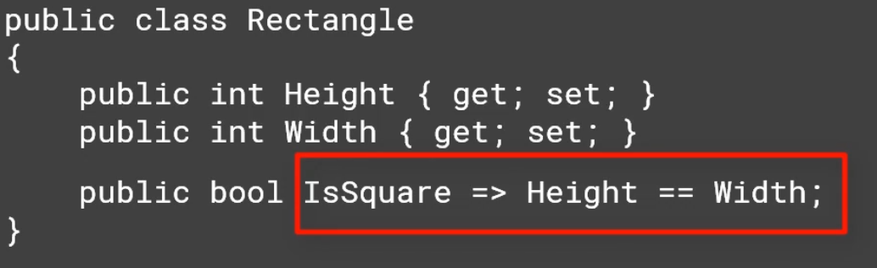

Another option is to have another separate type for square without any dependency. This would require a separate CalculateArea() method for square.

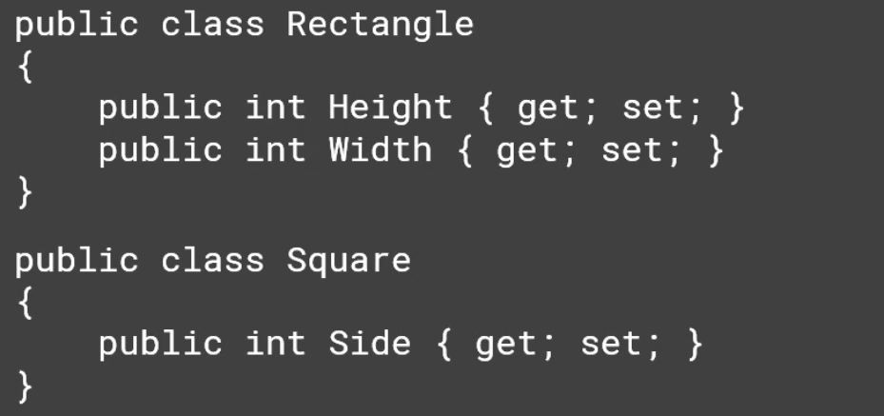

In real-world applications, if you are checking the type of a variable using the is or as keywords, inside of code that should be polymorphic, meaning it should work with a type or any subtype of that type, that is often a clue that LSP is violated.

Another violation of LSP is Null checks.

The third common violations is the NotImplementedException. Anytime we see this exception, it is an indication that an interface or a base class is only partially supported and some of its features were left unimplemented. This is also a symptom of violating the Interface Segregation Principle.

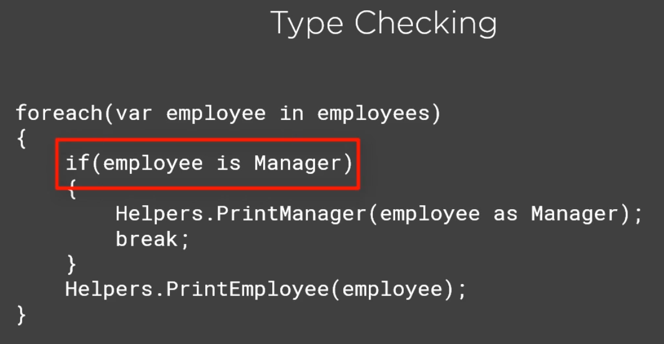

The actual type of employee in this loop example should not be important to the code. Any subtype should be substitutable for the base employee type. But here, the if statement check for if the employee is Manager type and if it is, the loop treats it differently and calls different method.

The biggest Problem with this code is it tends to repeat itself. It will manager check for every employee. Later, additional subtypes might be added like Director, Executives etc and you might have to revisit everywhere these checks exists to add additional behaviour to support these new subtypes.

Obviously, this violates the open closed principle.

This can be corrected by ensuring all subtypes of employee are substitutable. One way to do this is to have a separate type implement custom functionality in its own way.

In this case the Print functionality can be moved from the helper into the type itself. Be careful not to violate the single responsibility principle when following this approach.

Another option is to adjust the Helpers method so that it can work with any kind of employee.

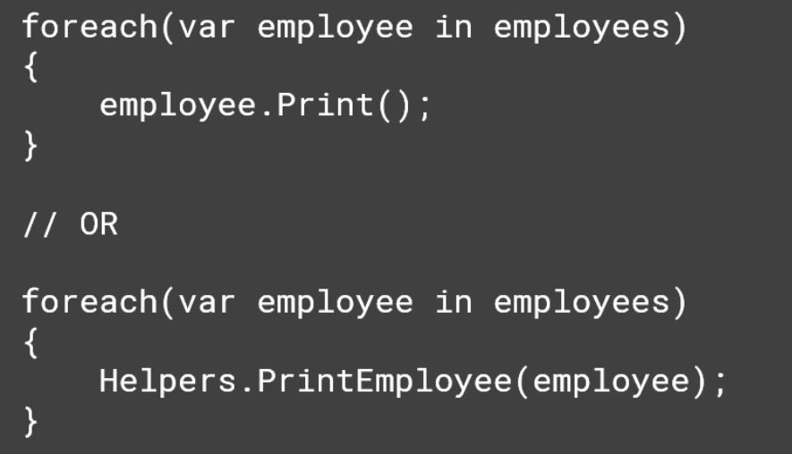

Similarly, checking for null is also the same behaviour as checking the type.

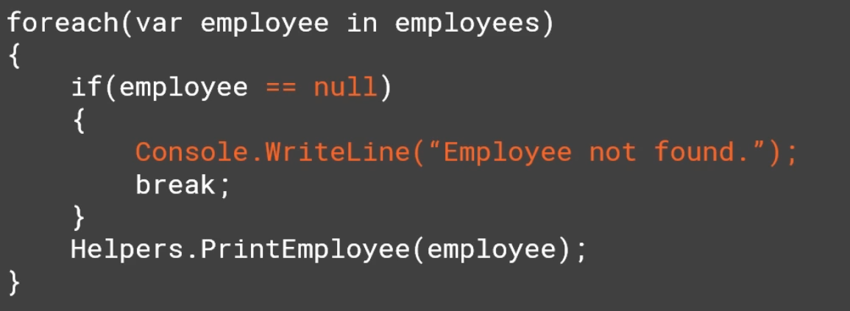

If you have one set of behaviour you expect to call when you have instance and a different set of behaviour you want to call when the instance is null is an LSP violation as well. You can use the Null object Design pattern to avoid the need for null checks.

Nulls break polymorphism and Liskov substitution principle. (<https://ardalis.com/nulls-break-polymorphism> )

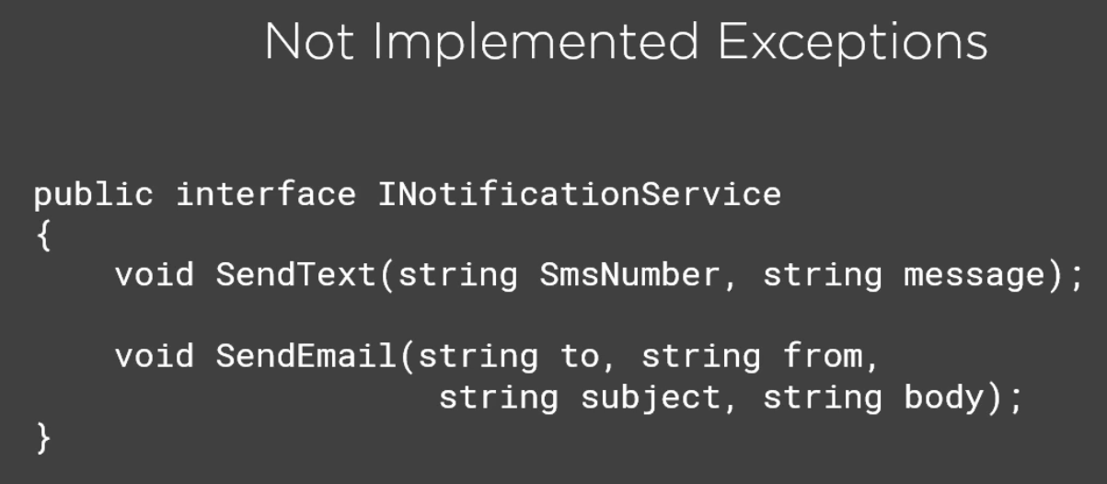

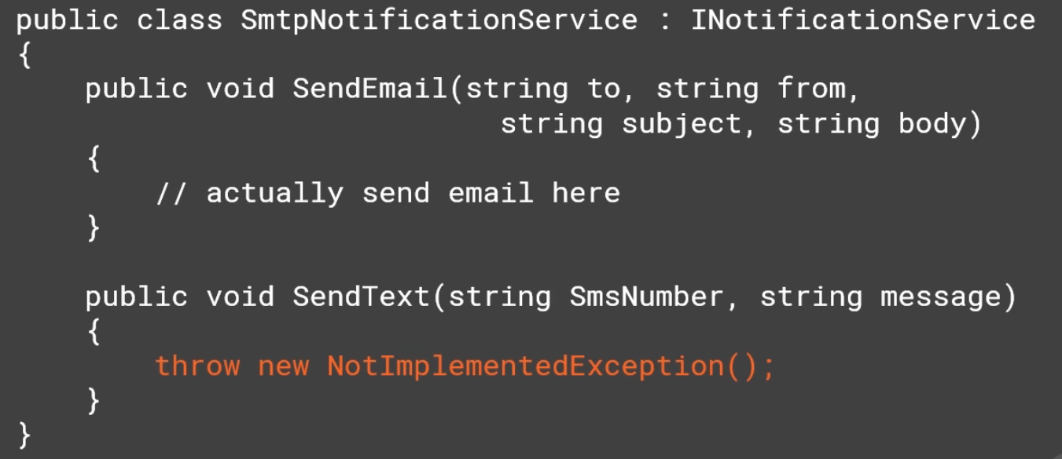

Because of the NotImplementedException, this SmtpNotificationService is not substitutable for INotificationService anywhere it might be used because some places might call SendText().

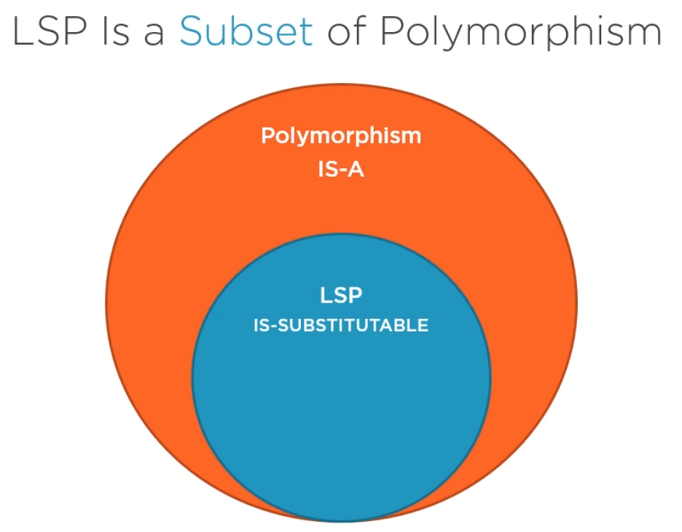

All types that support LSP also supports polymorphism. Anywhere you want to use polymorphism, you also want substitutability. So null references and other LSP violations break polymorphism because polymorphism that doesn’t follow LSP is itself kind of broken.

**Fixing LSP violations**

1. Follow the “Tell, Don’t Ask” principle.

Don’t ask instances for their type and then conditionally perform different actions but instead encapsulate the logic in the type itself and tell it to perform an action. Packaging state and behaviour together is a basic principle of OO design and tell, don’t ask is a great way to remember this.

1. Minimize the null checks with
   1. Nullable reference types
   2. Null conditional operators
   3. Null coalescing operator.
   4. Null object pattern
2. Whenever you implement an interface or inherit from a base class, make sure you fully implement it. If you are finding this difficult then this is probably because the type in question is violating the interface Segregation Principle.

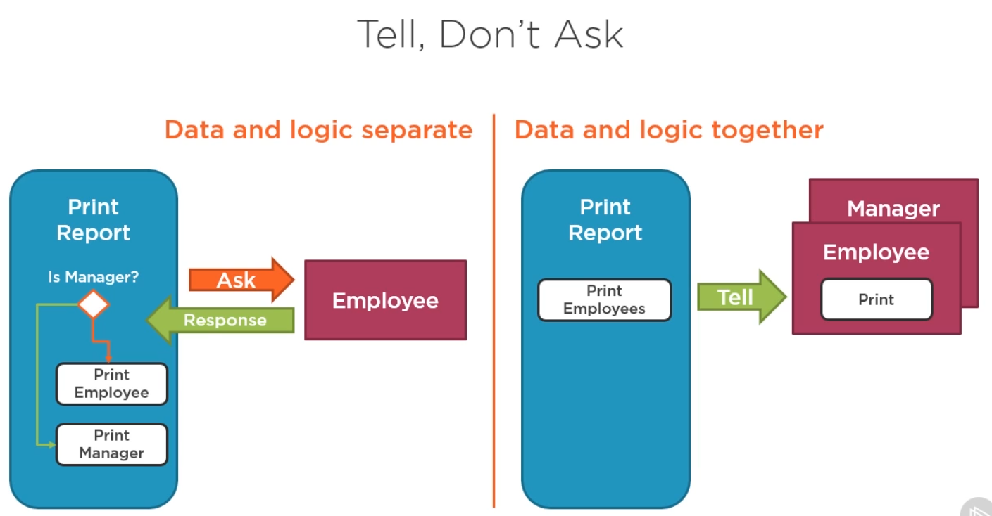

Now Let’s apply the LSP to the ardalas insurance project.

When we applied the Open closed principle to our project, we introduced a factory to create different policy rater instances through switch statement and also through Reflection so that we wouldn’t even need a switch statement inside of our factory.

With the Reflection, if we didn’t find the matching type we returned null. We worked past that by using the null conditional operator on the rater instance.

The code runs and doesn’t produced a rating but its behaviour isn’t 100 percent the same as the original code.

In the original code, if no matching type of policy is found then we logged “Unknown Policy type”. We are no longer outputting this message when the type doesn’t match.

We can overcome this by putting an If statement in the rating engine checking for the rater to null and outputting the string.

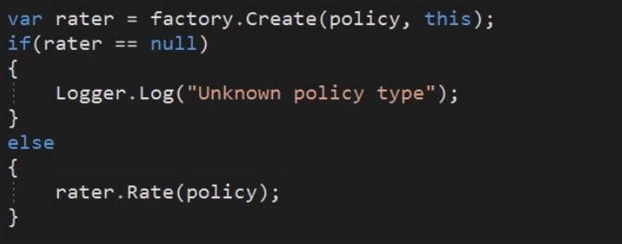

This is great but now we are violating the LSP because we have to treat null differently than how we treat other instances. Since the only behaviour we need in the case of an unmatching policy is to log something and take no other action, we can easily get this by applying the Null object pattern.

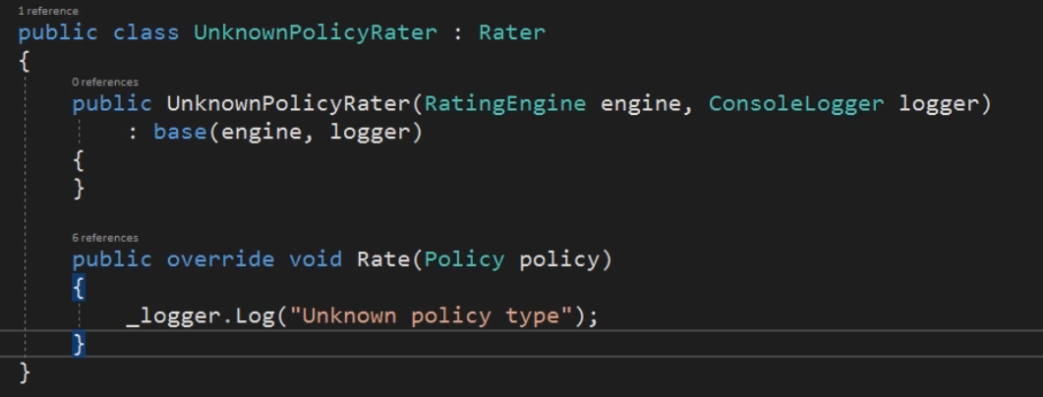

Then we modify the factory to return an instance of Unknown policy rater in case of no matches.

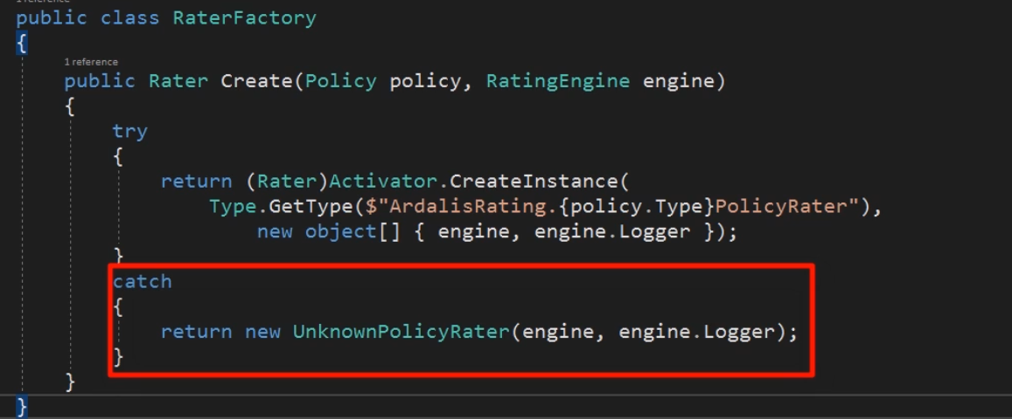

After this change the RaterFactory no longer returns null in any case so we can get rid of the nullable operator check from the ratingEngine.

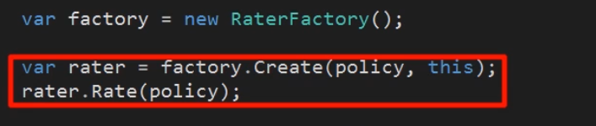

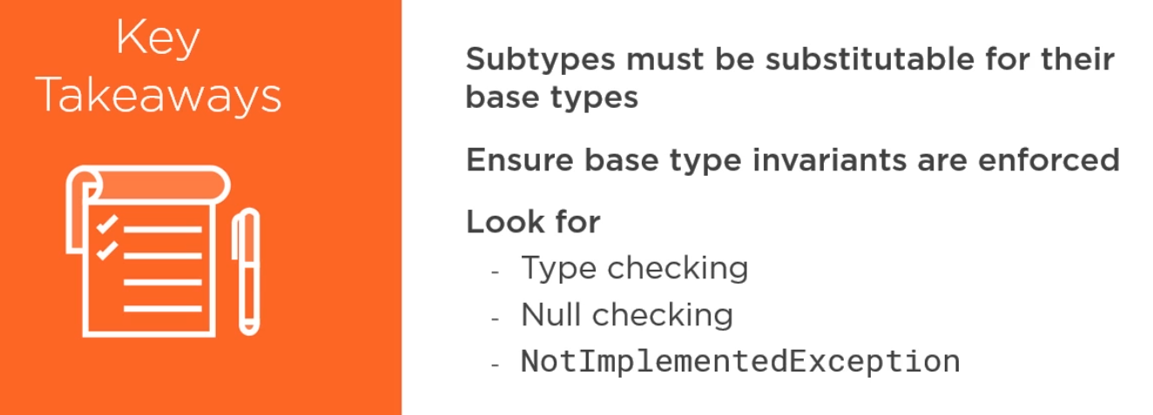

## Interface Segregation Principle

It describes how we should design and use interfaces in our application. We know from LSP that the LSP is sometimes violated by partially implementing the interfaces.

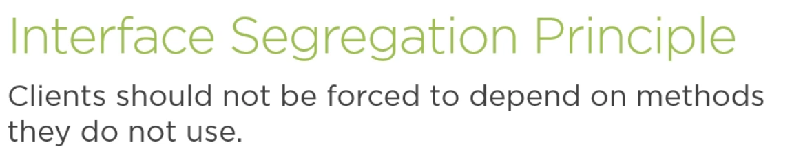



Similar to SRP, as we break our classes into smaller more cohesive ones, this principles also says the same.

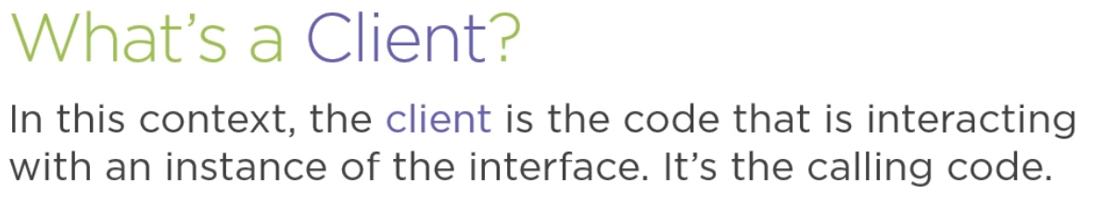

ISP says that your code should not depend on methods of the interface instance that it does not use.

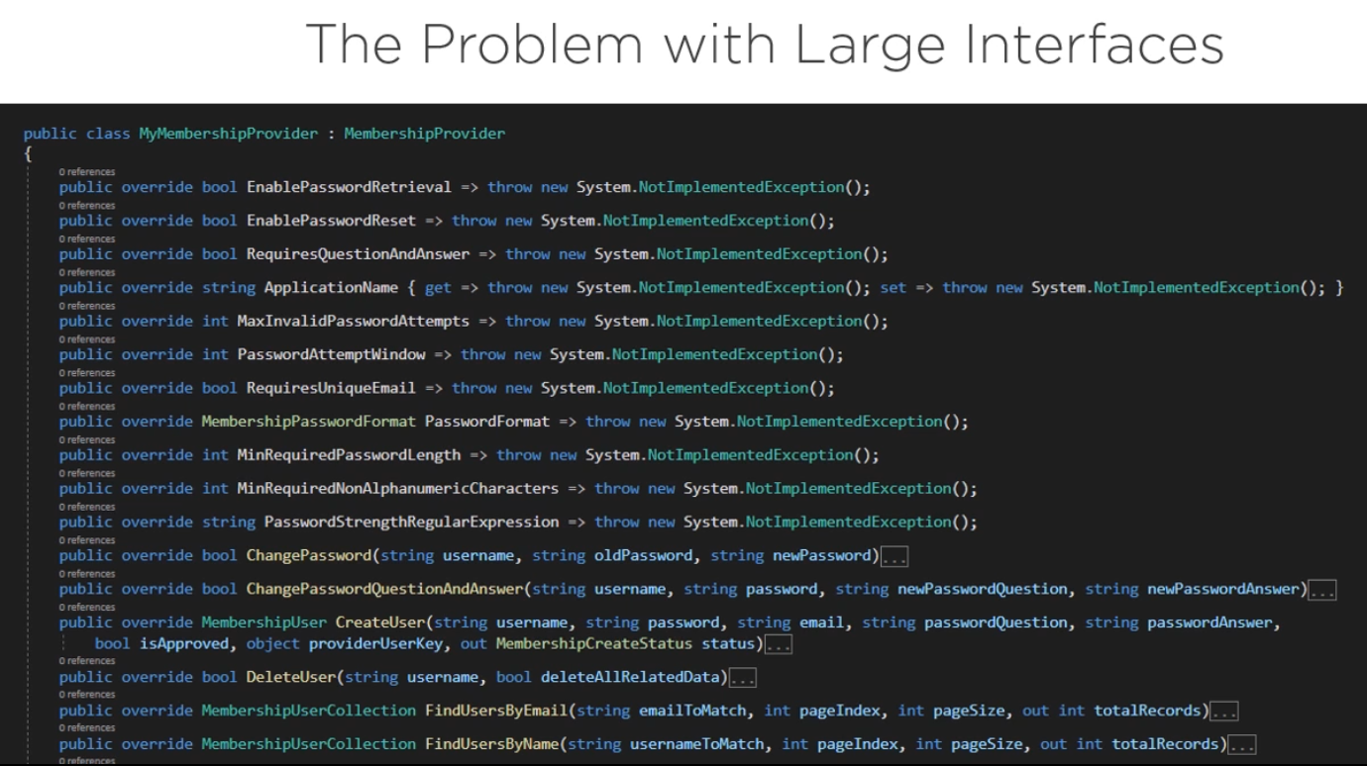

It shipped with the ASP .NET 2. And by default, Microsoft only supported SQL server. If your want to use Oracle or Active Directory then you have to implement your own provider by overriding the MembershipProvider type.

This class has about a long list of methods you need to override in order to fully implement your own provider. Also, we now know that not implementing some methods means we are breaking LSP.

Violating the interface Segregation principle results in classes that depend on things they don’t need and don’t use.

This increases coupling and makes it harder to change or swap out individual implementations because the number of clients that might break is much larger. That’s because it includes clients that depend on the interface but aren’t even using some parts of it, which might be the parts you are changing.

Large interfaces result in more dependencies.

More dependencies result in more coupling.

Code becomes more brittle because of the increased coupling.

Client code that depend on large interfaces can become more difficult to test.

Changes to type that implement these fat/large interfaces will involve more testing of downstream dependencies, thus, making deployments more difficult and riskier.

**Detecting ISP violations in your code**

1. Look for Large interfaces.
2. Not Implemented Exception
3. Look for code that uses only a subset of larger interface.

**Remember that interface does not mean the interface, but also base classes**

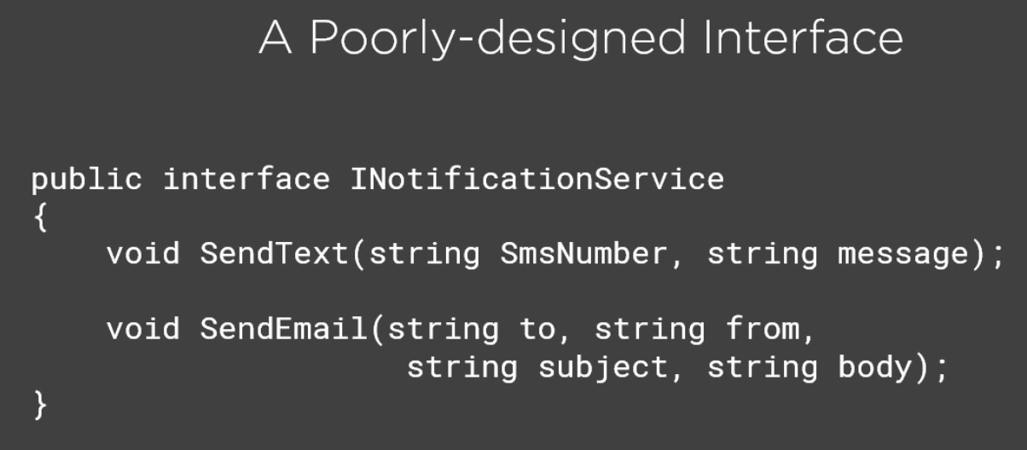

This interface is not a large interface but it lacks cohesion. This becomes clear when some client uses this interface and is only interested in sending email and not in sending text.

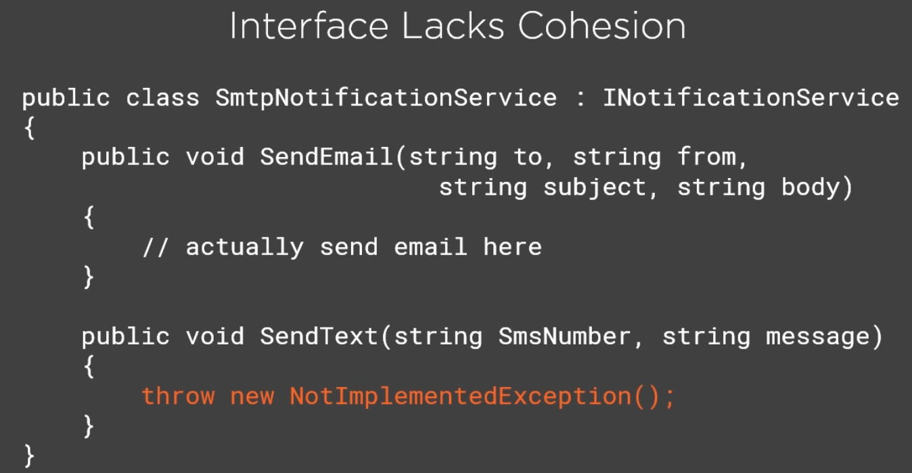

This is why the client code does not implement this method. So this interface is partially implemented.

You can easily address problems like this by breaking up the interface into smaller, more cohesive interface.

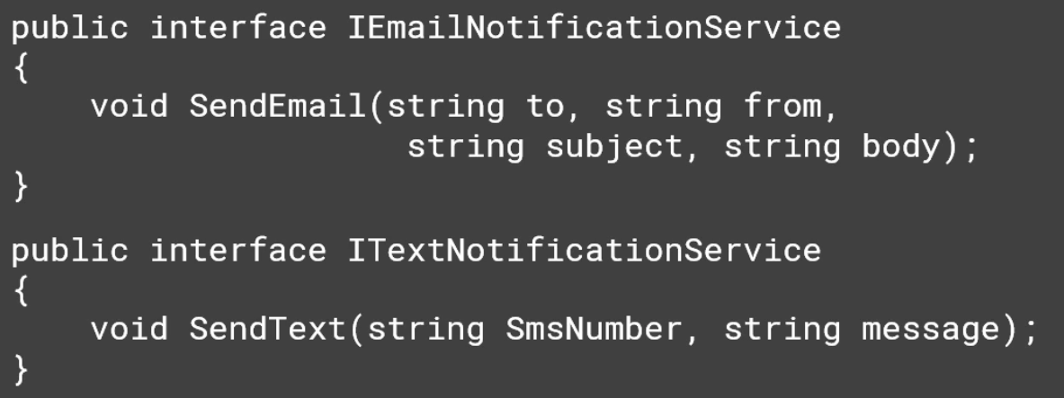

This technique can also be applied to larger interfaces. But what about the legacy code that is already using the first INotificationService interface with the 2 methods.

Breaking the interface will break the legacy code and since it can be used in many places, it is not an easy task to replace all those. So, one can’t use this technique.

This is not a problem at all. C# has always supported multiple interface inheritance from the start.

You can use this to pull out any number of smaller interfaces from a larger one and then simply add the smaller interfaces to the original interface using inheritance.

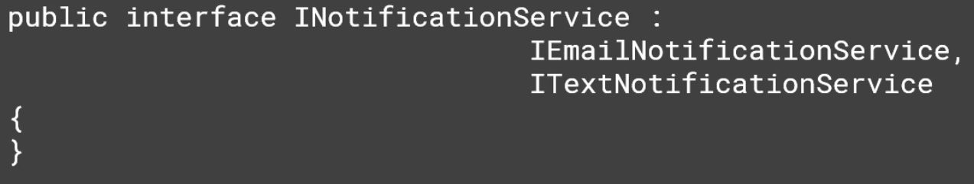

Now the INotificationService inherits from the IEmailNotificationService and ITextNotificationService. The body of INotificationService does not have any methods, but it continues to have the same signature that it used to have before.

Any clients that depended on the INotificationService will continue to work and compile just like they did before.

You cant apply this to interface that comes with the SDK. In those cases, the best approach to use is the **Adapter Design Pattern** and introduce your own interface that you do control.

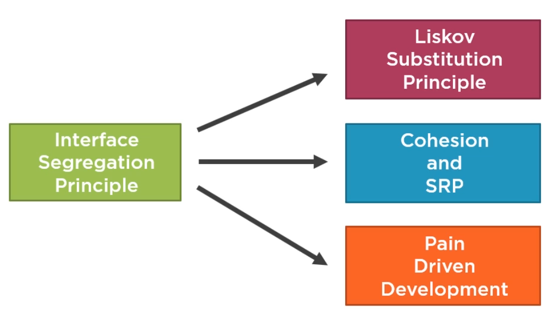

Fixing ISP Problems

1. Break up larger interfaces into smaller ones. Compose the larger interface from smaller ones for backward compatibility.
2. Follow adapter design pattern for interfaces you can’t control. Your code should interact with the adapter and only the adapter should know about the underlying large interface.
3. Clients should own and define the interfaces.

Now, Applying ISP to ArdalisRating application

Suppose now that the development team has introduces a Rating context class for the RatingEngine to use.

The ISP often gets overlooked in terms of real-world utility.

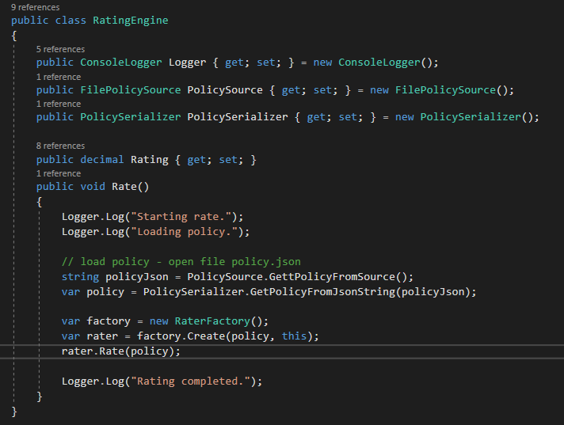

Our RatingEngine class currently has separate properties for its logger, policysource and serializer. Now the development team has pulled these out into a single context type named as IRatingContext interface.

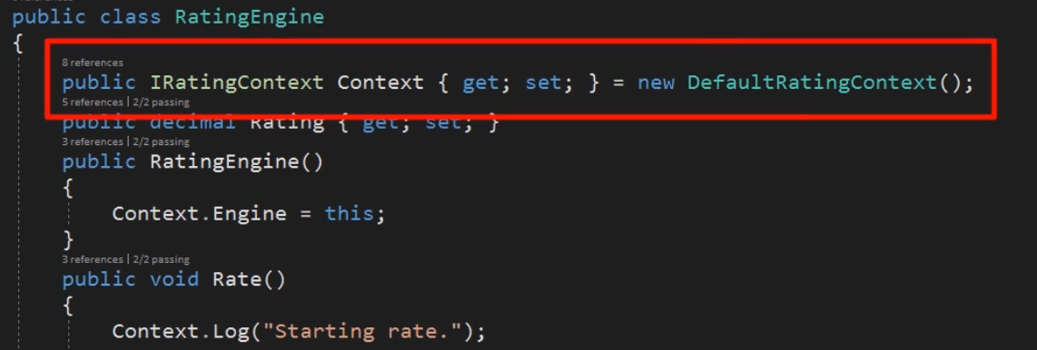

There is a DefaultRatingContext class that implements this interface for this application. There are other applications that have different implementations of this defaultRatingContext.

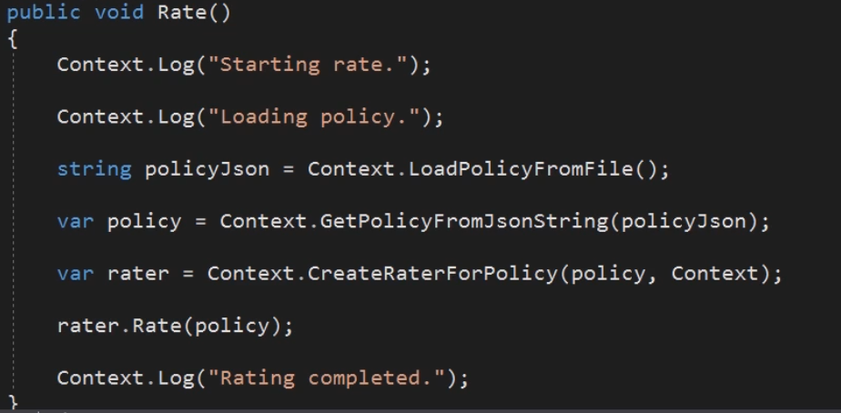

Looking at the Rate() method of the RatingEngine class, almost every line calls a method on this new Context interface.

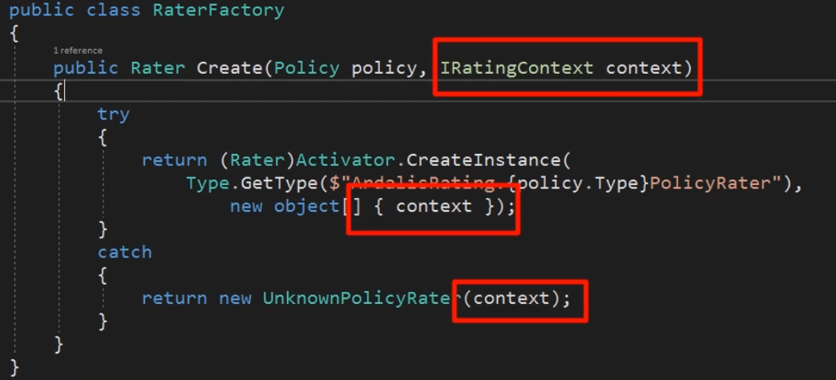

Likewise, the RaterFactory also uses the context interface now, as well as all the individual PolicyRater types.

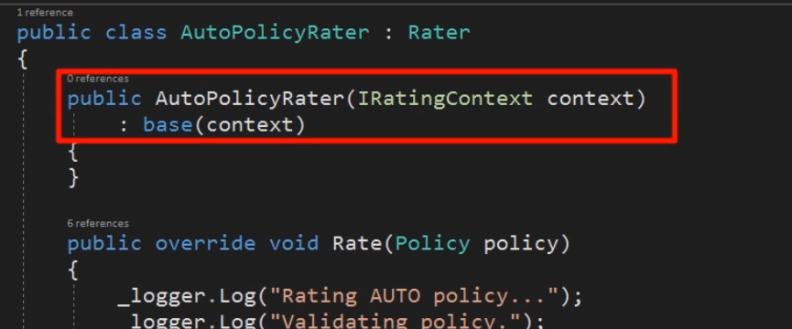

The base Rater class still exposes a consoleLogger probably for backward compatibility, but now that logger just comes from the context.

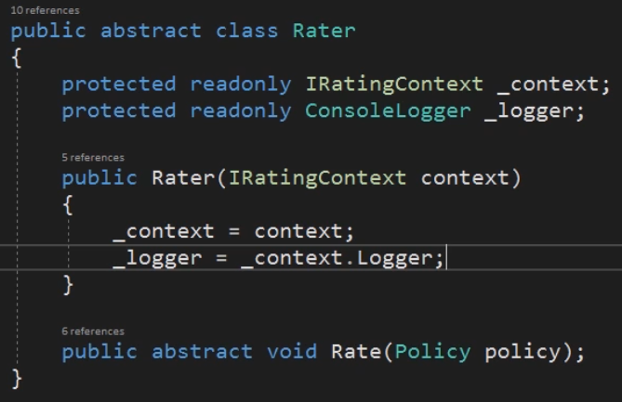

This kind of context class is not unusual especially in applications that don’t use dependency injection. The convenience of having a single class in which to put all dependencies and common code frequently turns the class into a junk drawer of methods and almost always ends up violating the single responsibility principle. The class also tends to be depended on by all kinds of other classes, making it very difficult to change in the future for fear of breaking any of its many dependencies.

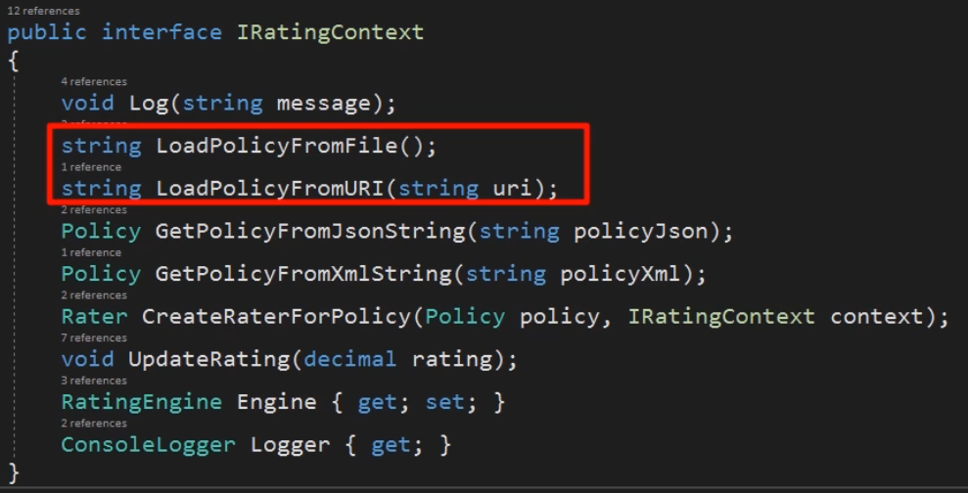

Looking at the interface itself, we see that it has 9 methods and properties with responsibilities ranging from logging to data access to serialization to object creation. It also exposes the properties for the Engine and logger it’s using.

Having side by side methods for loading data from different sources (marked in red) or deserializing using different formats is a problem addressed by Dependency Injection.

Exposing both a log method and the logger itself makes a clumsy interface since client code isn’t led to use the Log method directly versus the logger property’s log method.

Generally, you don’t want to give clients multiple ways to accomplish the same task in a single interface. It just causes confusion and potentially bugs.

When we look at the implementation of the interface, we notice that there are couple of not implemented method in the class. This sure is a sign that the interface is too big.

internal class DefaultRatingContext : IRatingContext

{

public RatingEngine Engine { get; set; }

public ConsoleLogger Logger => new ConsoleLogger();

public Rater CreateRaterForPolicy(Policy policy, IRatingContext context)

{

return new RaterFactory().Create(policy, context);

}

public Policy GetPolicyFromJsonString(string policyJson)

{

return new PolicySerializer().GetPolicyFromJsonString(policyJson);

}

public Policy GetPolicyFromXMLString(string policyXml)

{

throw new System.NotImplementedException();

}

public string LoadPolicyFromFile()

{

return new FilePolicySource().GettPolicyFromSource();

}

public string LoadPolicyFromURI(string uri)

{

throw new System.NotImplementedException();

}

public void Log(string message)

{

new ConsoleLogger().Log(message);

}

public void UpdateRating(decimal rating)

{

throw new System.NotImplementedException();

}

}

A quick review also shows that the Log method and the Logger property aren’t even linked together.

They each instantiate their own separate ConsoleLogger(). This could easily result in bugs in the future if they were to be changed independently from one another. Since the main functionality of our system is done by individual rater classes, it would be great if we could easily unit test these.

Unfortunately the dependency on IRatingContext and the use of the concrete COnsoleLogger make writing these tests difficult.

**Applying ISP to the application**

First, we need to identify what Rater instances are using. Which methods off of IRatingContext do they require.

Rater abstract class require the IRatingContext and from it uses the logger. Looking at the AuroPolicyRater, we notice that it only calls the UPdateRating() method of the context.

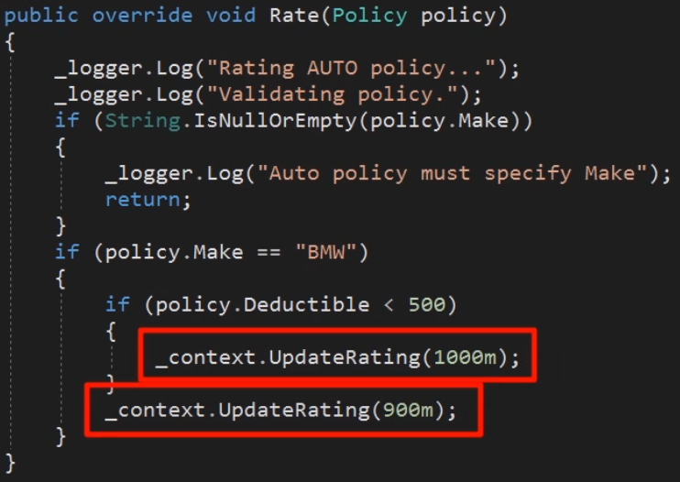

Only method on the logger being called is Log(). With this in mind, we could create an interface with just these 2 methods on it. But combining UPdateRating() and Log() into one abstraction doesn’t sound very cohesive at all as both these methods are not linked in any way. We would be better off with two different instances.

Let’s create an ILogger interface with the Log method. We will then update the ConsoleLogger class to use this interface. Then we modify Rater to use ILogger instead of ConsoleLogger.

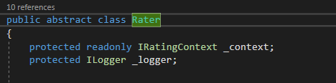

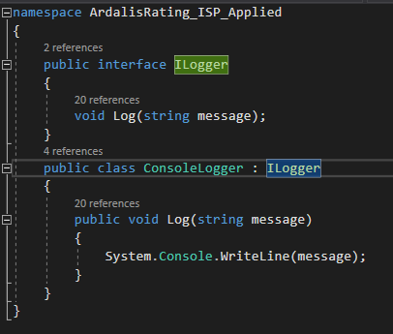

Now we have a few choices of how to initialize this ILogger in the Rater abstract class. We can just instantiate this in Rater which will glue it to the ConsoleLogger. **Remember new is glue – *which needs to be avoided.***

We can also make it a settable property and default it to consoleLogger. This will give us the current behaviour in the production but would let us modify the property in our tests.

We can also follow the explicit dependency principle and take the ILogger as a constructor parameter.

Let’s implement it as a property for now.



To finish this change, we just need to update all the _logger.Log() to Logger.Log() in our PolicyRater classes.

We also can now remove the Log method from IRatingCOntext and instead have that interface inherit from the ILogger.

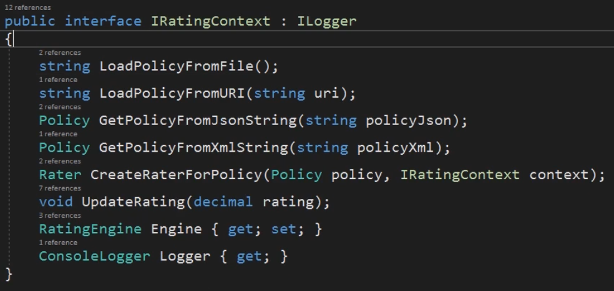

Next, we can pull out an interface to replace UpdateRating().

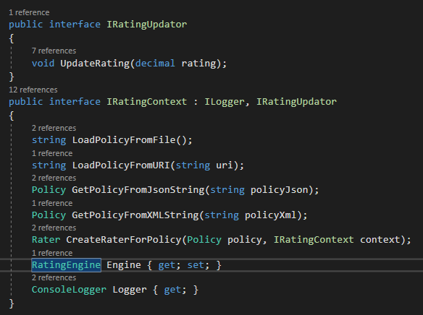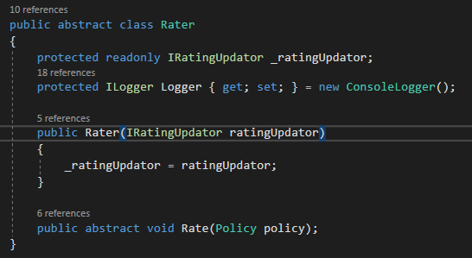

Now we can go the the Rater abstract class and have it use the IRatingUpdator interface instead of the IRatingUpdator interface as the other PolicyRater classes only uses the UPdateRating() method on the context.

Now we can apply these changes to all other PolicyRater classes.

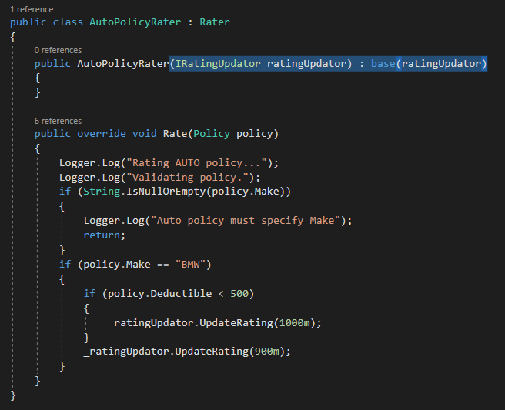

Looking at the IRatingContext again, we know that we can now remove the IRatingUPdator inheritance from it and also the Logger property as it is not being used now from the context implementation.

The final code looks like this.

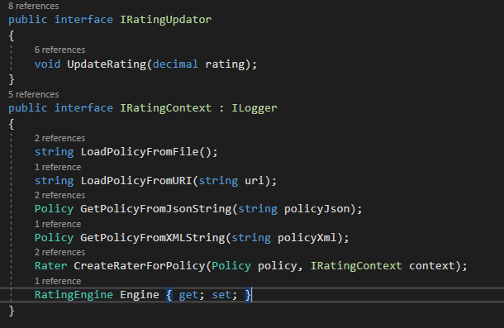

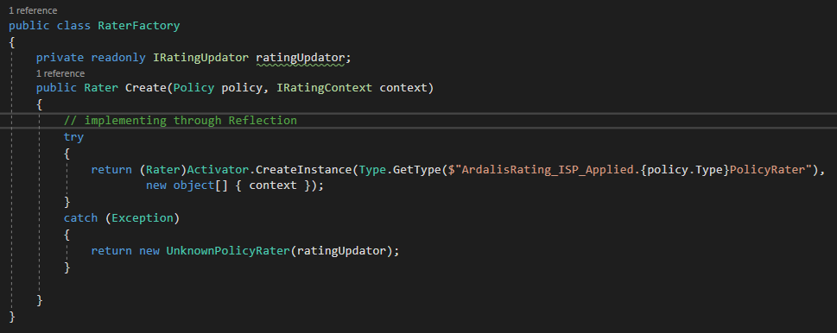

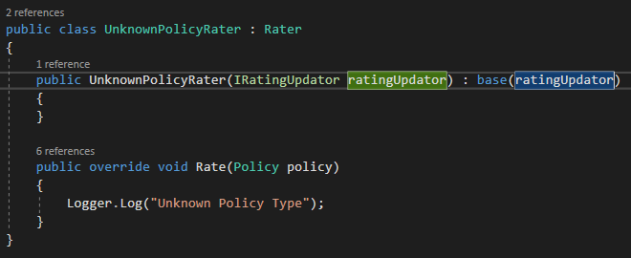

internal class DefaultRatingContext : IRatingContext

{

public RatingEngine Engine { get; set; }

public Rater CreateRaterForPolicy(Policy policy, IRatingContext context)

{

return new RaterFactory().Create(policy, context);

}

public Policy GetPolicyFromJsonString(string policyJson)

{

return new PolicySerializer().GetPolicyFromJsonString(policyJson);

}

public Policy GetPolicyFromXMLString(string policyXml)

{

throw new System.NotImplementedException();

}

public string LoadPolicyFromFile()

{

return new FilePolicySource().GettPolicyFromSource();

}

public string LoadPolicyFromURI(string uri)

{

throw new System.NotImplementedException();

}

public void Log(string message)

{

new ConsoleLogger().Log(message);

}

}

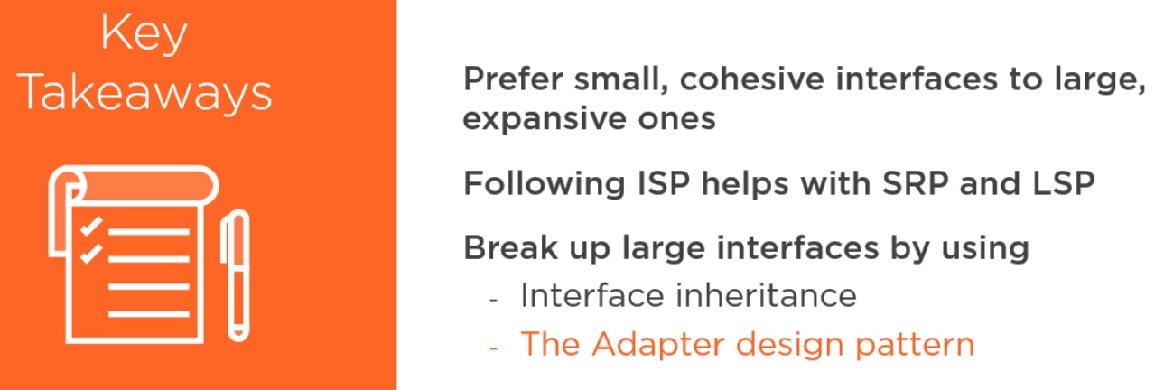

## Dependency Inversion Principle

This principle is critical for creating loosely coupled, maintainable software of any significant size.

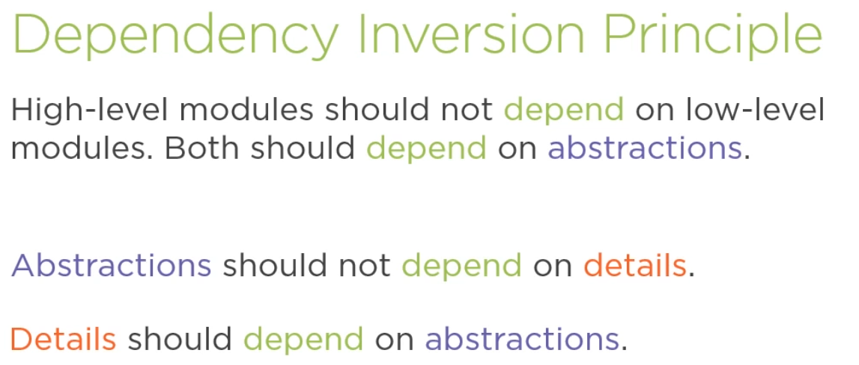

There are two kinds of dependencies in C#.

1. Compile Time
2. Run Time

The dependency inversion principle mostly has to do with compile time dependencies.

If your application is built using multiple projects in a solution, your project references will point in the direction of your dependencies. If you follow DIP these references should point away from your low level infrastructure code and towards the high level abstractions and business logic.

The key is to ensure your infrastructure project depends on interfaces that live in a separate core project, and it should have the abstractions your front end application will use.

Avoid having your UI project use infrastructure concerns like data access libraries directly.

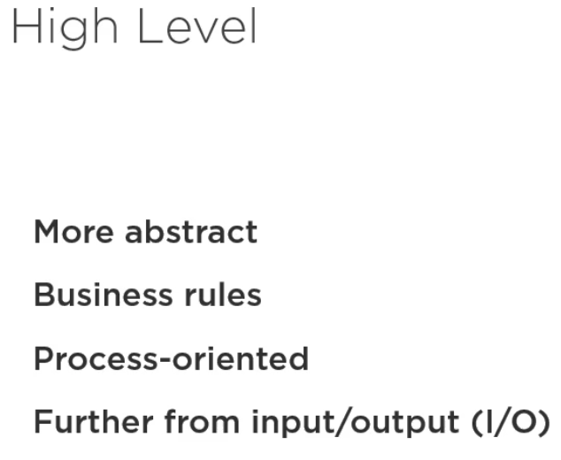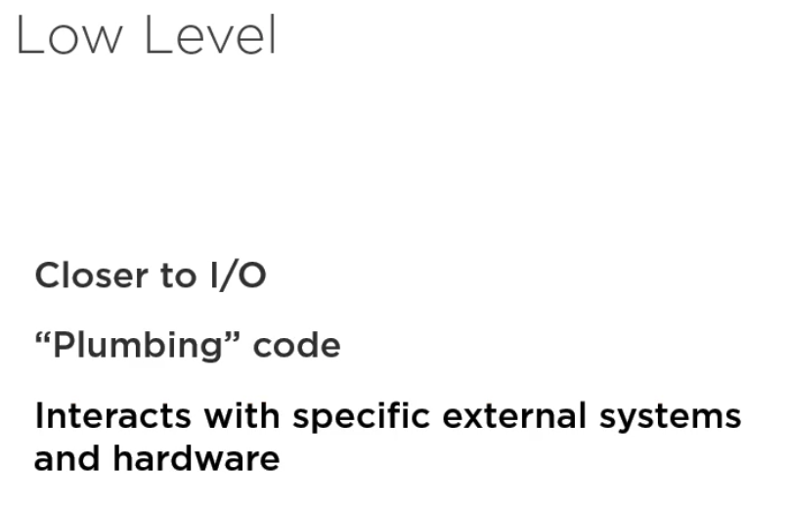

The DIP is all about separation of concerns. High level concerns like your domain model or business rules should be kept separate from low level concerns like plumbing code that knows about all the details of your UI or systems layer.

Your system abstractions are generally going to be high level concerns so make sure they don’t depend on low level concerns.

Abstractions in C# refers primarily to interfaces and abstract base classes. Interfaces are generally preferred because they don’t require object inheritance so they are a bit more flexible. Essentially the things you can instantiate are concrete while the types that describes a way to work with that type but don’t actually perform the work are abstract. This means that types that you can’t instantiate are abstract.

The abstractions just defines a contract, a way of working with a type without actually specifying how that work is going to get done by having a specific implementation of that contract.

Abstractions should not be coupled with details i.e. they should not know about the specifics of how they are implemented. **Abstractions describes what.** Details specify how.

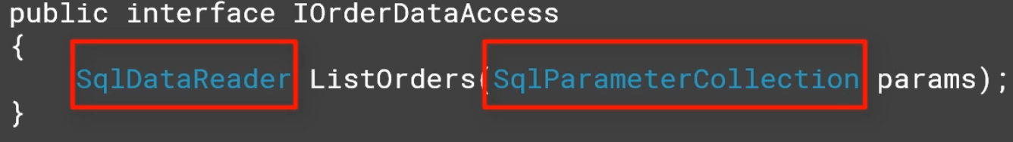

This interface is an abstraction of accessing order data. Because it is an abstraction, it shouldn’t care how that data is stored, so long it is able to provide the data. This interface however, returns a SqlDataReader and takes in a SqlParameterCollection exposing implementation details and making the interface much less reusable.

Any client that uses this interface must now take a dependency on ADO .NET in order to use it.

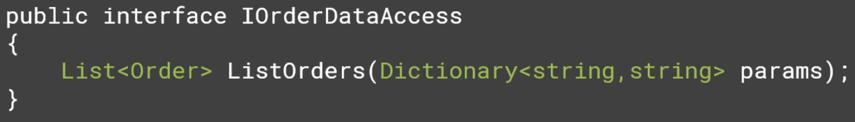

Modifying this interface like this corrects the problem. It now hides the details of hoe the data might be accessed or stored.

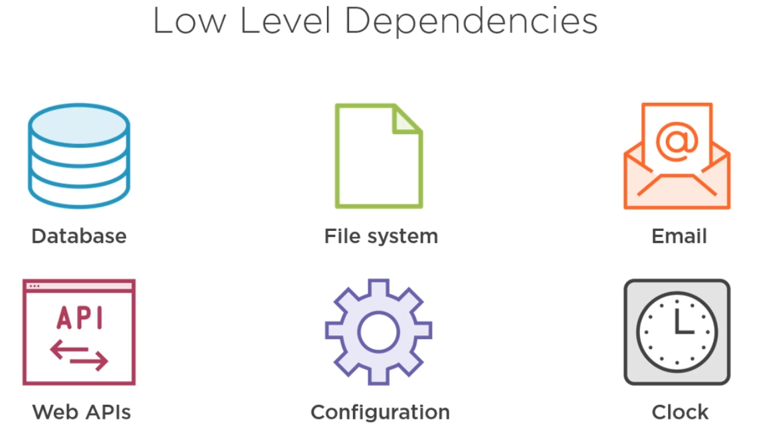

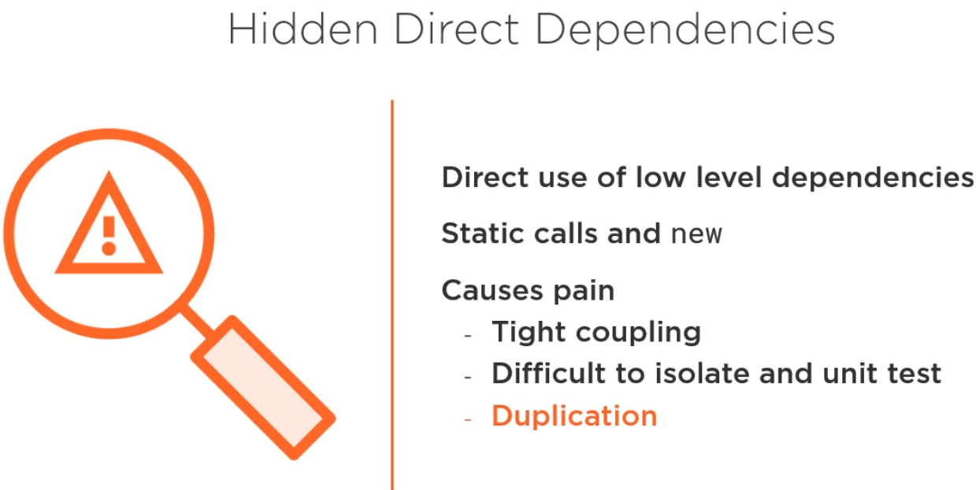

Now let’s look at the effect abstractions have on dependencies. How these dependencies very between compile time and run time. With no interfaces or abstractions shown here, classes will reference the classes they directly instantiate and work with. Then at run time the call graph will mirror this dependency relationship.

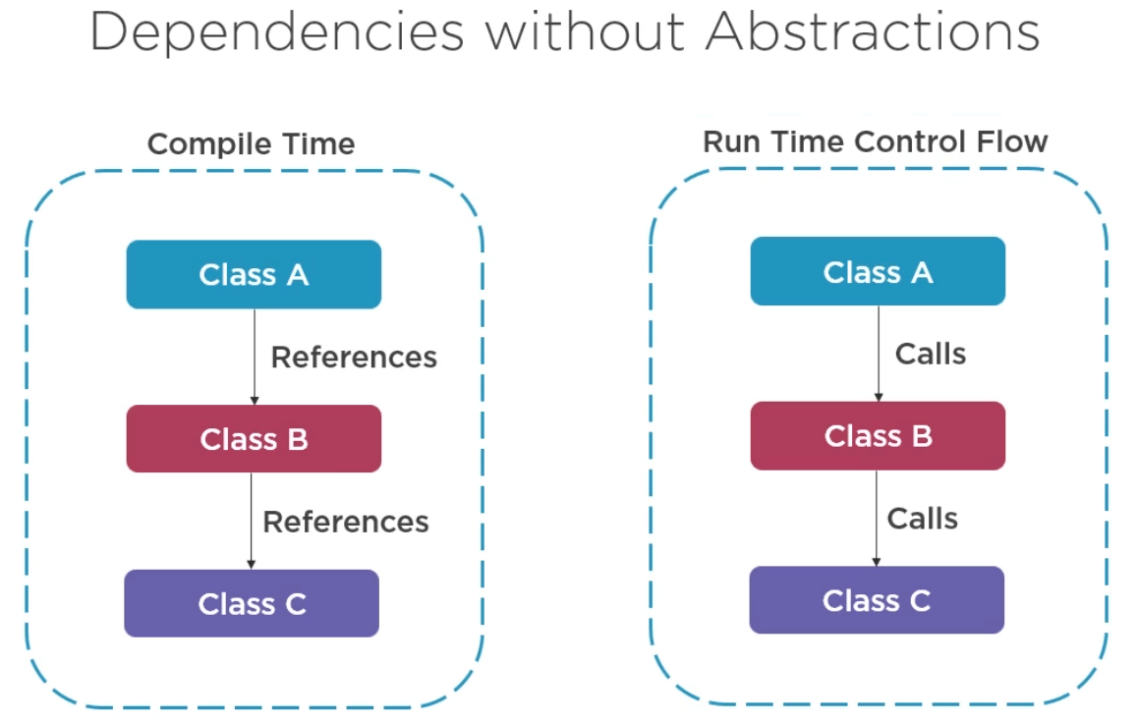

With the addition of interfaces, the dependencies at compile time are inverted. Class A no longer depends on Class B, and Class B no longer depends on Class C. this is now because we can remove both the class and have Class C and Class D implement the interface respectively and it will have no effect on the class A.

All the classes now depend on the two new interfaces. At runtime, the system behaviour can remain the same. With Class A calling into Class B and Class B calling into Class C. but now we have gone from tight to loose coupling.

The Dependency Inversion Principle often goes hand in hand with a programming technique, dependency injection which is sometimes referred to as DI.

The explicit dependency principle says you shouldn’t create your own dependencies as this introduces tight coupling between them. Instead you should depend on abstractions and request them from client software. Client code injects your classes dependencies ideally as constructor arguments but sometimes using other means like properties or method arguments.

The dependency injection technique is an implementation of the Strategy Design Pattern.

It is preferred to use the constructor injection because it has several advantages over using a property or method parameter to specify a dependency.

1. It follows the explicit dependency principle by ensuring client code is aware of what dependencies the given class has.
2. It ensures an instance of a class is always in an initialized state. A class that requires a property to be set before it can be used isn’t nearly as intuitive to work with and will require more checks in client code to ensure its dependencies are set before it can be used. It’s best that services that have dependencies are immutable so that once created, you don’t have to worry about whether they still have what they need to work.
3. Constructor Injection allows your code to leverage special factory types called IOC or DI containers. You configure these containers to map between abstractions and implementation types, and when your application runs, the container is used to instantiate types that have dependencies. The container is able to resolve the dependencies of your classes at runtime, providing a very flexible way to manage your dependencies between objects.

ASP .NET Core has a built in services collection as its container. You can use this directly or ou canreplace this by any third party container such as Autofac.



**Applying DIP to ArdalisRating**

We are going to focus on decoupling the rating engine from these details so that we will have a more modular, maintainable and testable system.

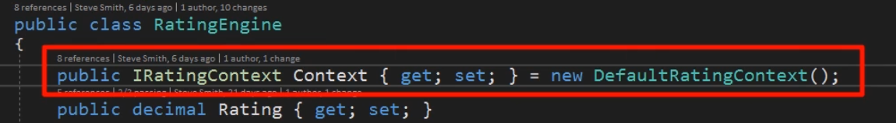

Notice that the RatingEngine currently relies heavily on the instance of DefaulRatingContext class for a lot of its functionality, including how it loads the policy data and how it deserializes it.

Now we are going to apply the dependency injection principle so that there isn’t the direct dependency from RatingEngine to RatingContext and its associated concrete implementations for these features.

***One new feature we are being asked to support is logging to a file rather than console.***

The Rate() method of the RatingEngine class first calls Log method on the RatingContext. Currently, there is no way to change how RatingEngine does logging other than by changing the class itself because it directly calls Context.Log, which in turn is glued to the defaultRatingContext class by the new statement.

The first step in applying DIP is to identify an interface using ISP and modify the code to depend on the interface rather than the concrete implementation. In this case we already have an ILogger interface that we can use.

Following the explicit dependency principle this time we will request an instance of ILogger from RatingEngine’s constructor

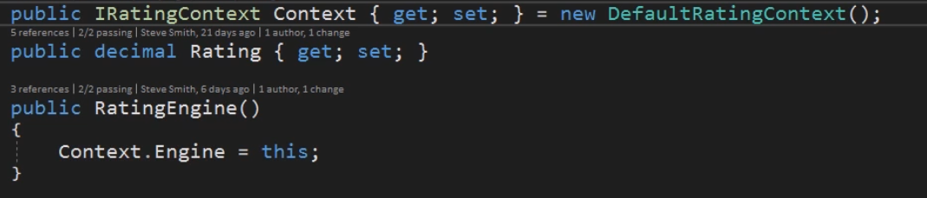

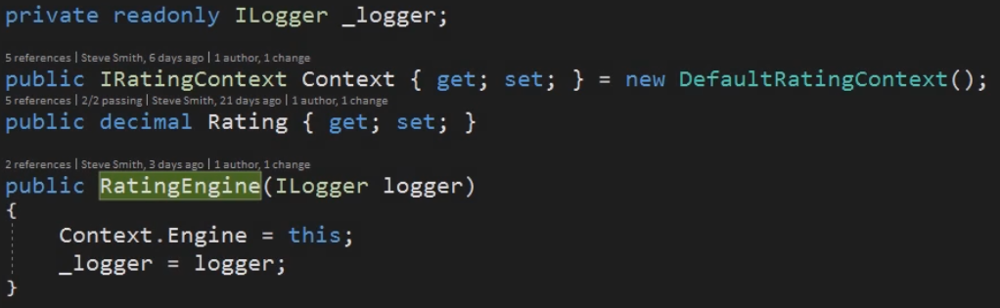

Now we can modify all the calls from context.Log to _logger.Log.

But now the current instantiation of RatingEngine in the Program.cs does not inject the ILogger into the RatingEngine. Building the solution will fail.

There are two ways to fix this.

1. We can use constructor chaining to provide a default implementation within the RatingEngine class. To do that we just create a new default constructor and have it chain to this ILogger parameter based constructor with a new logger

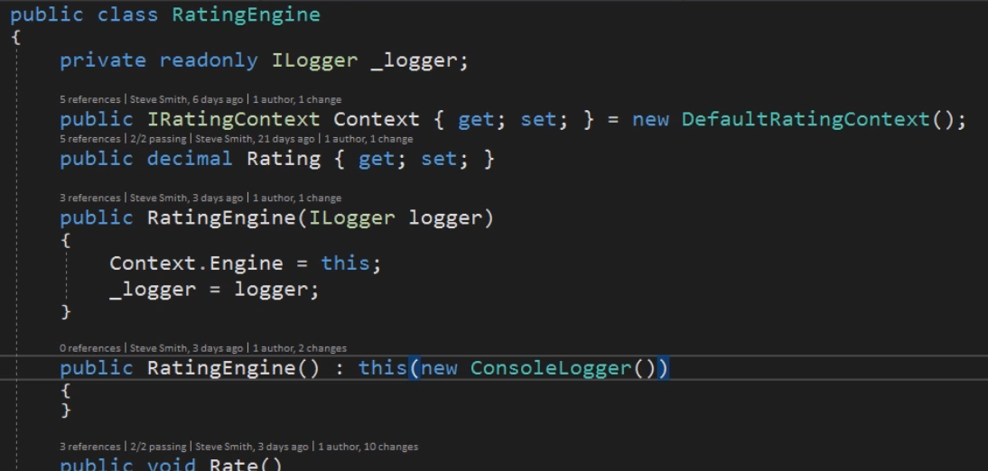

This is a good technique to use when you have a large legacy system and you want to start following the explicit dependencies principle, but you don’t want everything that currently creates the type to break. It’s not ideal though, because the dependency on the specific implementation is still there and the other classes that uses this default constructor are thus still tightly coupled to whatever concrete implementation is being used.

1. The better approach if you can manage it is to eliminate the default constructor and pass in the dependencies whenever instantiation occurs, or just let your DI container do it for you if you are using one.

In this case, we are only instantiating the RatingEngine in Program.cs only. So, it just makes sense to specify the dependency just like this. Once we do so, we also need to update any tests that instantiate RatingEngine, which is again a reminder that you should avoid duplicating your instantiation logic of your classes in your tests. So, we can remove the default constructor.

We have to inject the new ConsoleLogger() into the RatingEngine from Program.cs when we are instantiating the RatingEngine.

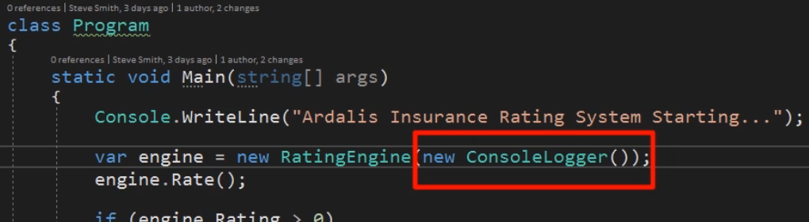

The only other places we need to perform the same type of change is inside of our tests.

Currently the DefaultRatingContext class is directly instantiating a FilePolicySource class in order to implement its loadPolicyFromFile method.

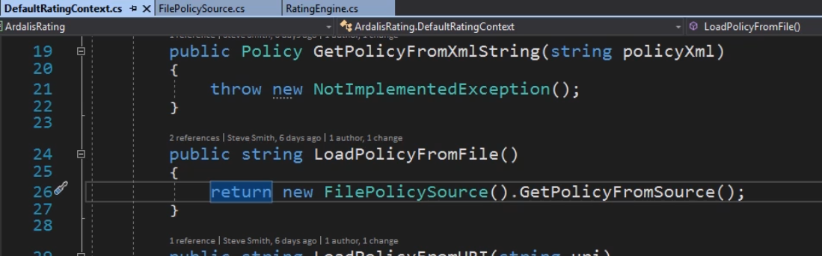

What we want now is to apply the dependency inversion principle and also use the Interface Segregation principle to extract an interface for this particular class that we can then implement in multiple ways.

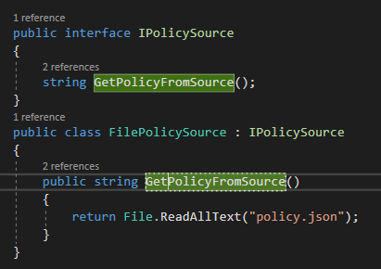

Now we would like to just compose this interface into IRatingContext, but unfortunately the methods don’t match up. IRatingContext has LoadPolicyFromFile and not GetPolicyFromSource. So, instead we look at the DefaultRatingContext to see how FilePolicySource class is used.

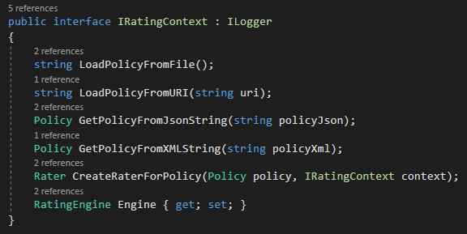

This is how it is implemented in DefaultRatingContext class

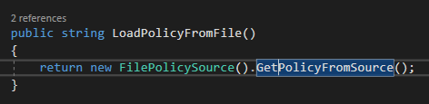

It just new up FilePolicySource. We can replace this instance with an interface field and populate it from the constructor.

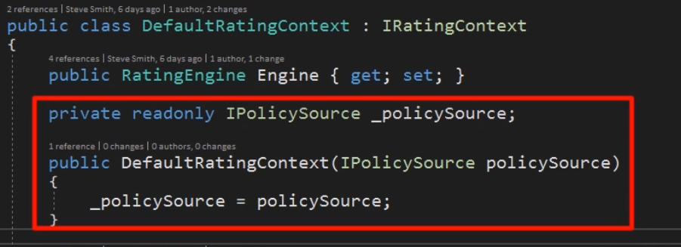

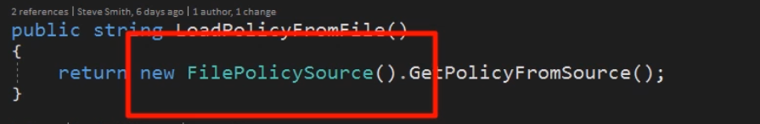

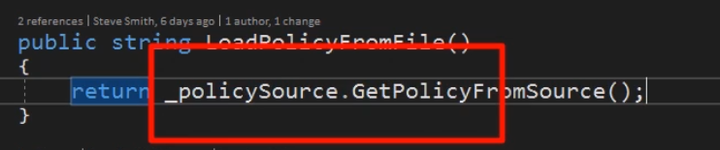

However we now get a compile time error when instantiating the DefaultRatingContext.

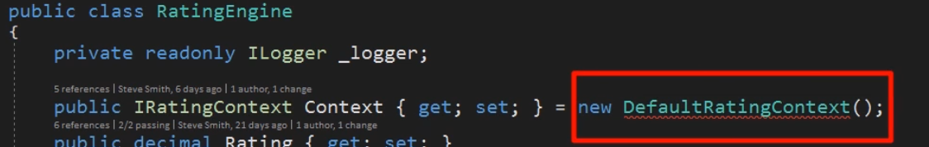

This is because now there is no parameterless constructor present in the DefaultRatingContext class. This class needs an injection of IPolicySource.

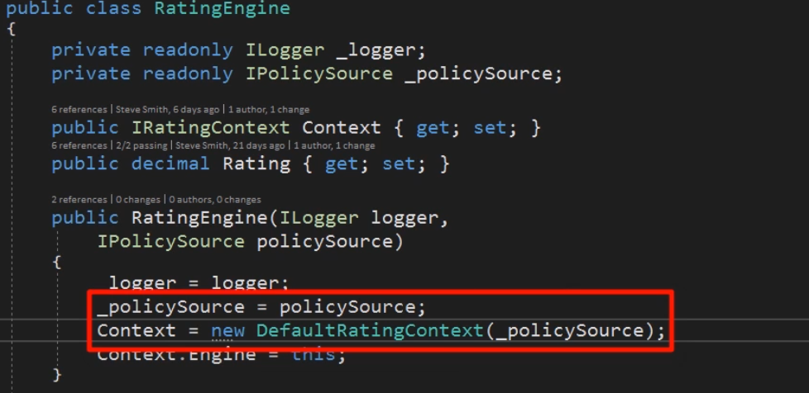

As soon as we do this and as we know that the program.cs instantiate the RatingEngine class, now it needs to provide the IpolicySource to the RatingEngine class through injection.

This is just fine because Program.cs is where we want to specify the implementations our app will use.

We fix this error by simply adding the new FilePolicySource that we want it to use at runtime.

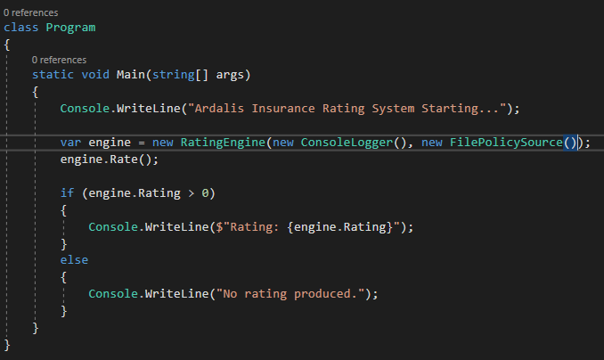

Now turning back to the Rate() method of the RatingEngine, the next use of context is when its going to use the serialization.

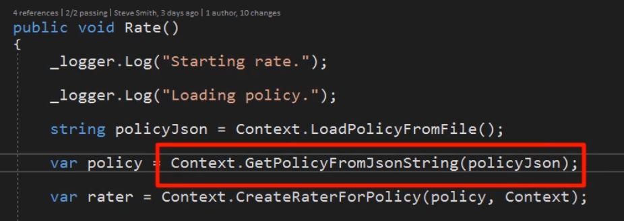

In this case, we are hardcoding it to get it from a jsonString and thus it is using the Json Serializer. We can use the same technique we used for the FilePolicySource to extract an interface for serialization and then inject it into our rating engine.

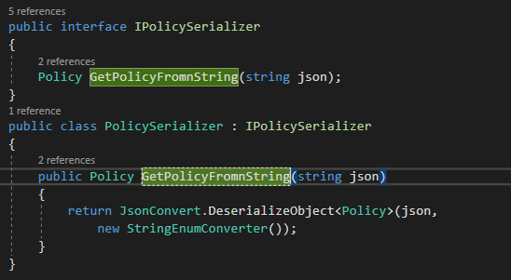

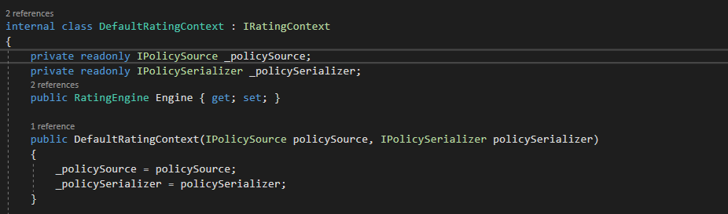

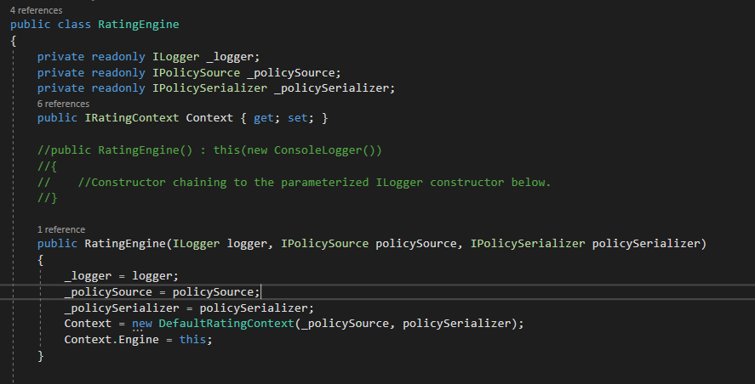

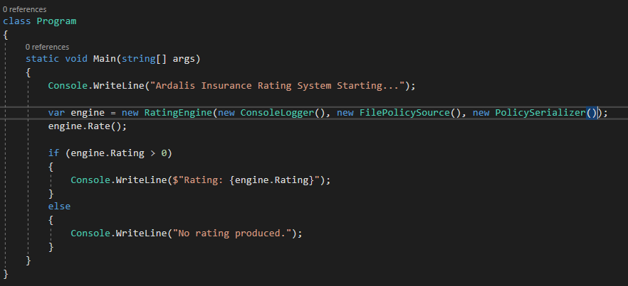

Now our Rate() method in the Rating Engine Looks like this

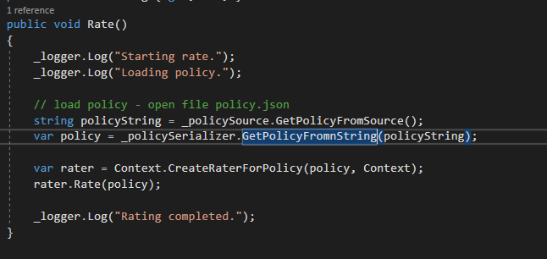

Our IRatingContext interface has shrink down to this level. It no longer depends on methods like GetPolicyFromJSonString. We will shrink it further down at the last.

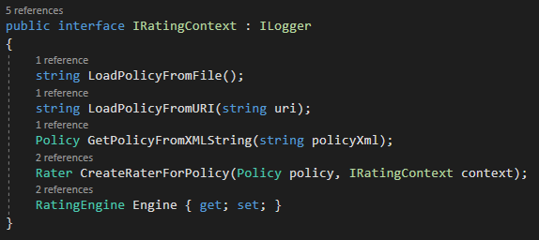

Now we need to clean up the Context instance for creating Rater in the Rate() method of the RatingEngine().

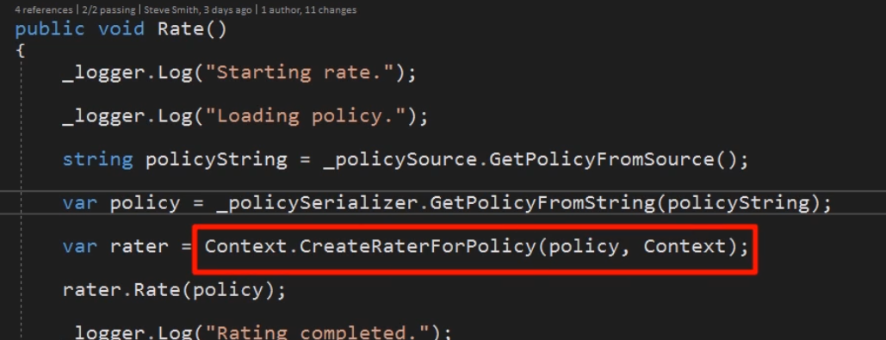

This is delegating to the RaterFactory we created previously. Looking at the Factory class we see that it needs an IRAtingFactory. And it is only using the Engine property on the Context.

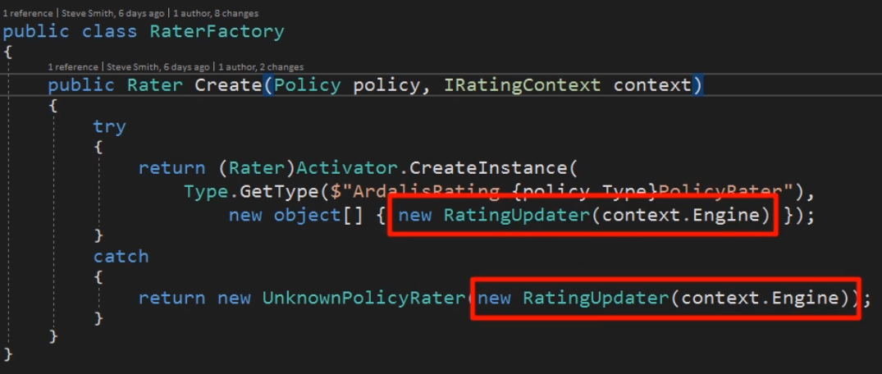

It needs this Engine to create a RatingUPdater. So, what it really needs is a RatingUpdater. Let’s just provide that directly as a constructor parameter. We already have an IRatingUPdater interface so we will pass that in to RaterFactory and then we make sure that we create it further up the call stack.

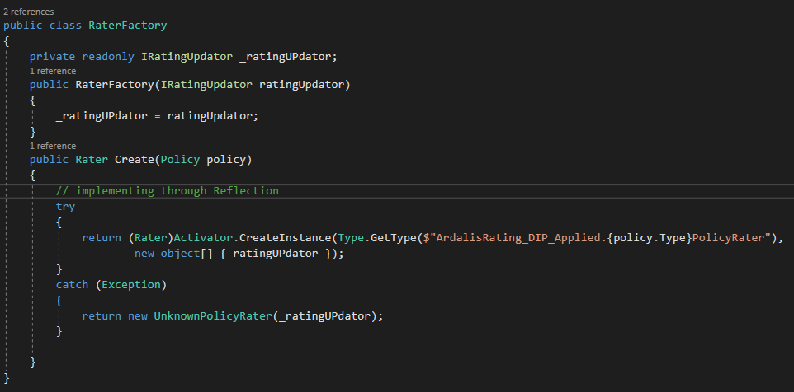

When we start injecting the RatingUPdator into the RaterFactor, it simplifies the create method so that now we can just pass that RatingUpdator into any particular policyRater type that we instantiate.

However, doing this brings to light an earlier design choice that wasn’t ideal, namely the way ratings are updated.

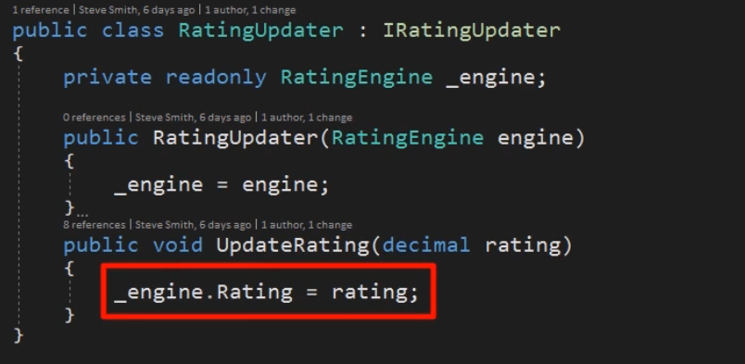

Our design as it stands now have RatingUPdator depends on RatingEngine, so it can update its rating property.

Creating a RatingEngine requires a RaterFactory, which in turn now requires a RatingUpdator. So, we have a circular dependency.

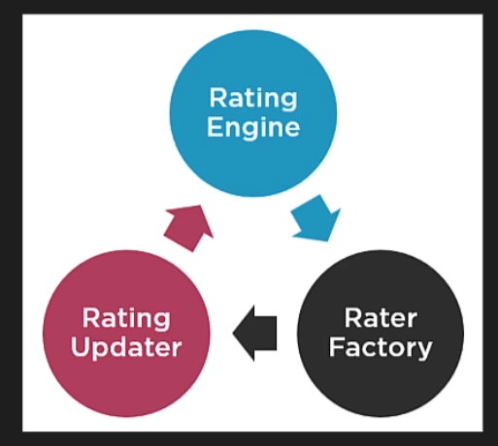

We got around this previously by using the property setters, but switching to using constructor arguments makes this problem more apparent.

The simplest solution is to remove the dependency from Rater to Engine by having Rater to simply return the rating. This would eliminate the need for an IRatingUpdator entirely. This is a fairly sweeping change to the system, but now the things are loosely coupled and testable. It’s a fairly low risk. Essentially we just need to change Rater so that instead of the Rate method being void, it return a decimal rating.

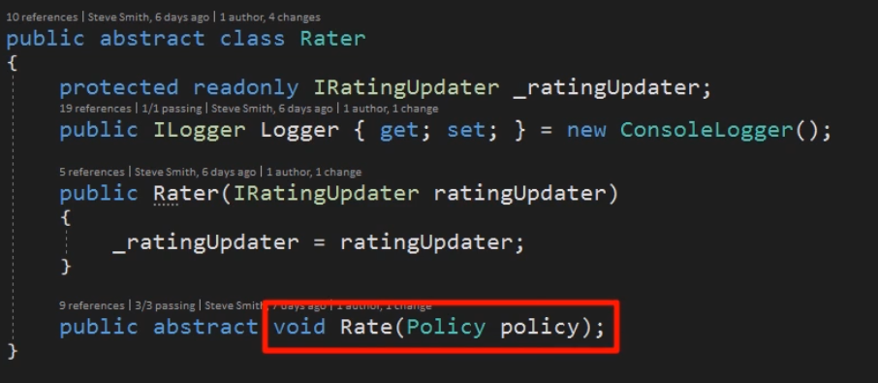

Currently when no rate is set, the RatingEngine Rate property remains its default of 0. So, we can return 0 without changing the current behaviour. If this weren’t the case, we could return the Rating result type that indicated success and then only set the property if the results were successful.

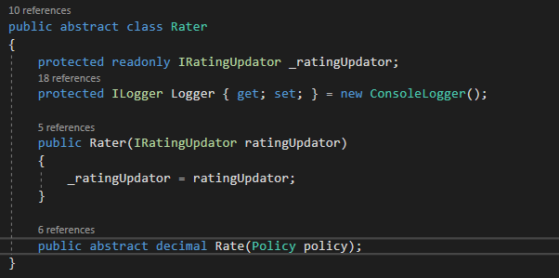

With this change the Rater no longer requires a RatingUpdator. It simply returns back the decimal type.

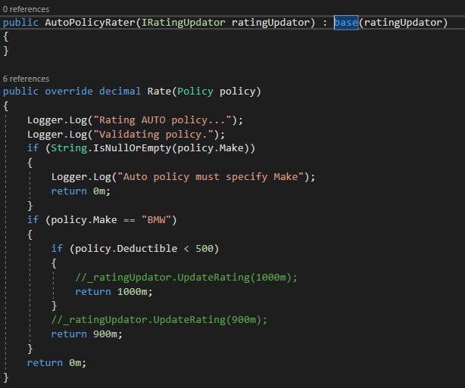

We also take this opportunity to change the Logger inside of the base Rater class from being hardcoaded to a new ConsoleLogger and instead having it inject in an Ilogger implementation.

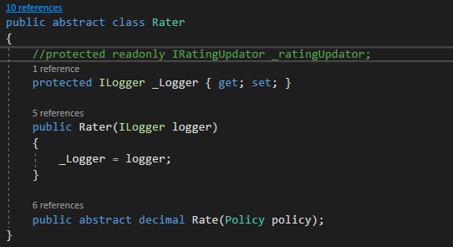

At this instant, when we go to create the ratingEngine, we just pass it in all of the dependencies it is exposing. It’s now following the explicit dependency principle. It’s telling us that it needs a logger, need some way to pull in data from a file or some other source of data. It needs some way to deserialize the data. In this case we are going to use json. And finally it needs some way to produce indivisual type of Raters we are going to use which we are going to provide a RaterFactory for.

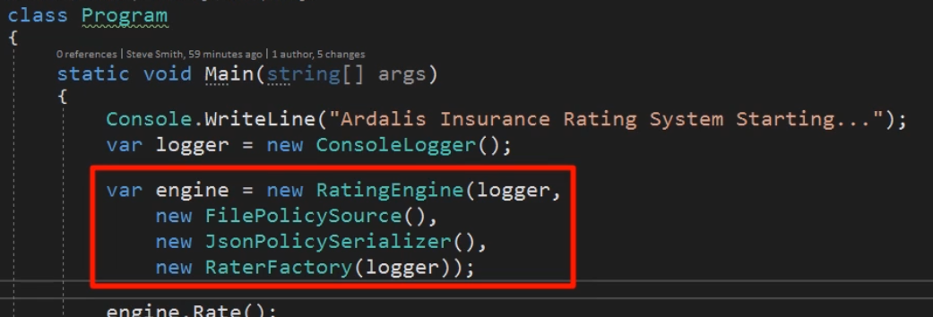

The RaterFactory also has a dependency on logger and in this case we are going to use the same logger for both of those case.

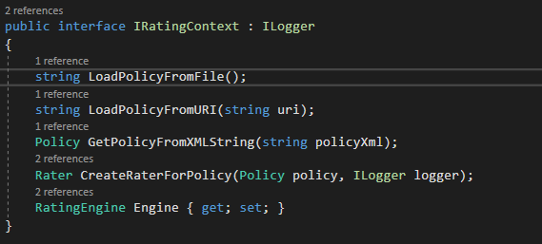

Now at that start of this, we were asked to implement something that can log to a file. Now we only need to change it in the Program.cs.

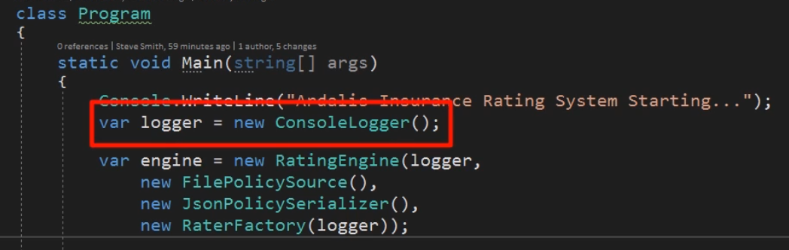

This is how the rating engine class looks like now.

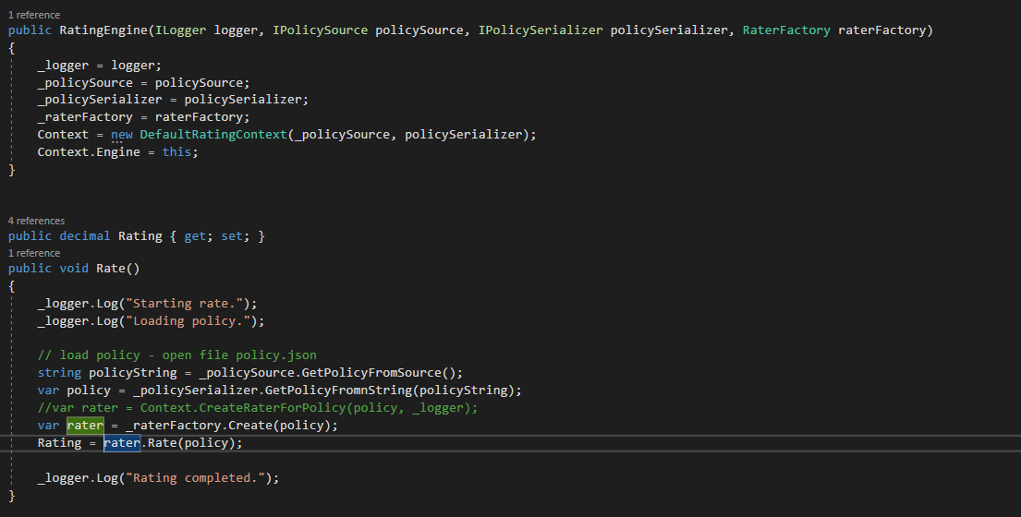

The change will automatically impact the entire system instead of us having to touch multiple different points where we were instantiating a ConsoleLogger and change that behaviour to use a FileLogger.

File logger will look very much like a console logger. Instead of writing to a console, it will write out to a particular file. In this case, our requirements didn’t specify that we need to have some configuration of what that log file should be so we are just going to use log.txt for now.

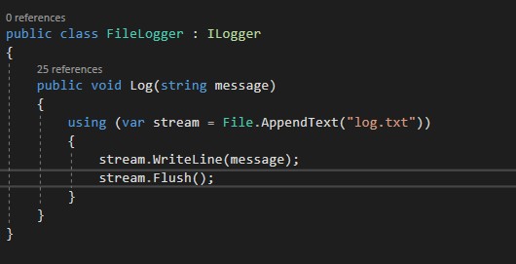

With this in place, we can change how the system outputs its log data by just going into Program.cs and changing the place where we instantiate the logger to use a FileLogger.

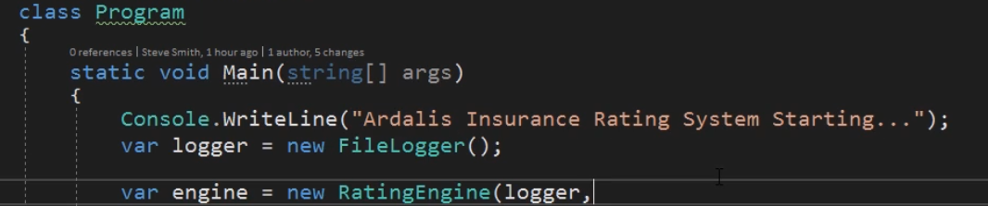

Now when we run this, the only output that comes into the console is from the program.cs .

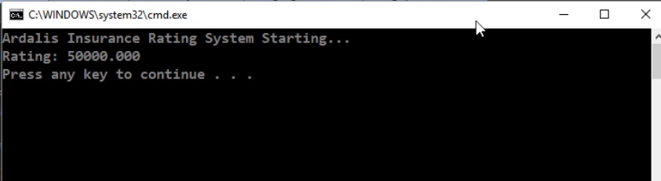

Following SOLID principles like SRP and ISP tend to result in smaller and more focused classes and interfaces. As a result, there are more number of files

Use folders to organize large number of files. You might put controllers in one folder and models in another. You might have a folder for interfaces and another for services.

There is another approach that works specially when application grows is to use feature based folders. With feature folder, your top level organization is by feature and not by the kind of file. For example an online store can have folders like catalog, search, cart etc instead of controllers, models etc.

Let’s say that we want to have a web front end that uses this console application. So, we can organize this console application files based on whether they are high-level or low-level, whether or not they are an abstraction or implementation, whether or not they are an entry point to our system. Or UI concern, or if they are some part of actual business rules that we are going to apply.

We will start by creating 3 folders

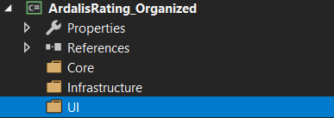

1. Core -> Business logic files that does not have any external dependencies
2. Infrastructure -> things that have dependency on specific implementation details like the File System
3. UI -> whatever my entry point to the system is.

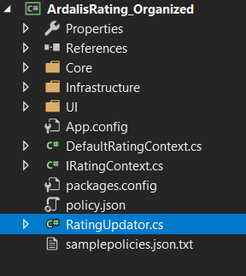 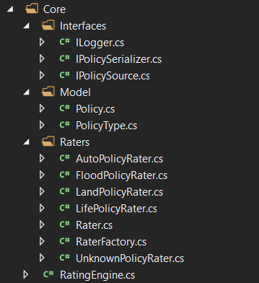

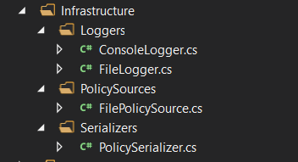 

Now looking at the files that are left outside the folders, we see things that we are no longer using.

DefaultRatingContext and its IRaitingContext interface, IRatingUpdator and RatingUpdator, we can just eliminate.

These can now be delete and it becomes obvious because they aren’t in any of the folders and nothing else is using them.

If there is a case where these files are being used by any other systems then we would move them either into a shared dlls or into a nuget package rather then deleting them.

So this is our final structure looks like

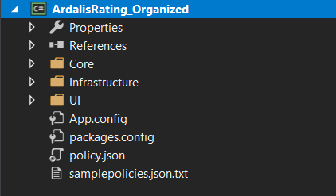

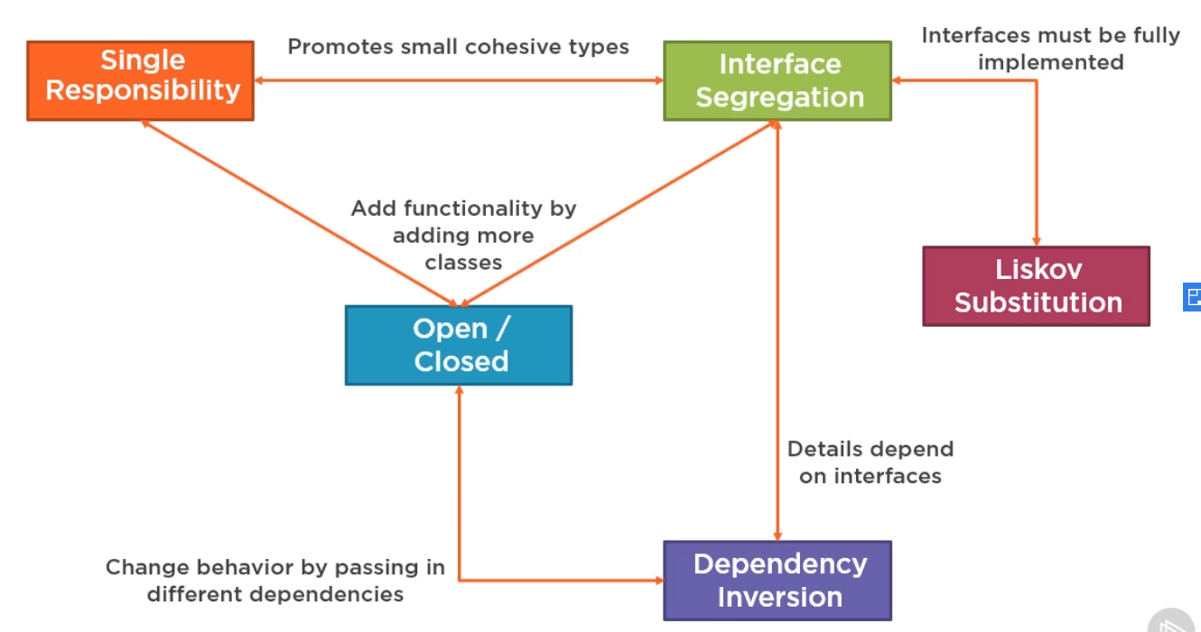

## Resources

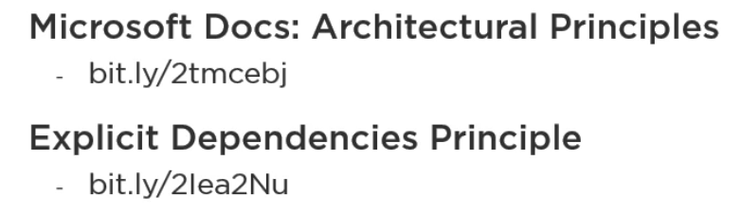

To see how to properly structure your solution and clean code by following these principles, look at the below references.

